Welcome to the Arc

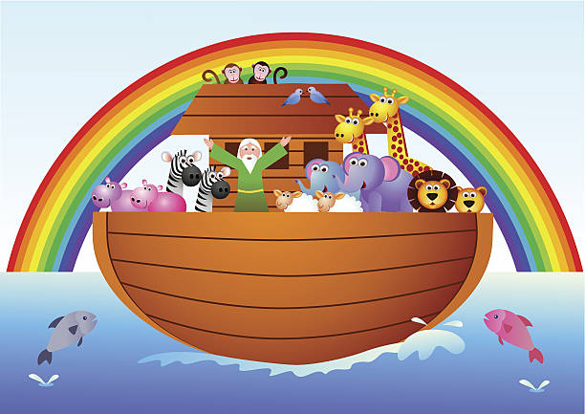

Meet the Staff
Head of Partnership Provision
Mrs. L Patmore

Mrs Patmore started the Arc. She is a mum of two and loves her holidays abroad. She enjoys reading and running. Mrs Patmore also has a very sweet tooth.
Family Support Worker
Mrs Michelle Barwick
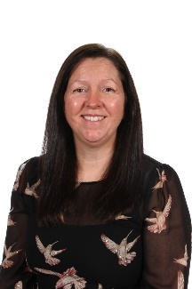
Mrs Barwick is a mum to three teenagers. She loves long walks and making people smile.
Lead Partnership Provision Specialist Teaching Assistant
Miss S Yeo

Miss Yeo has one son and loves spending time with her family. She likes going to the beach and enjoys studying.
Partnership Provision Specialist Teaching Assistants
Mrs F Thomas

Mrs Thomas is a mum of two girls. She likes walking, shopping and spending time with her family.
Ms T Bonici
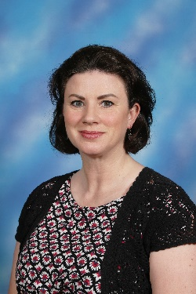
Ms Bonici has 3 fabulous children, one cuddly dog and two crazy cats. She enjoys dancing, singing and learning new languages.
Mrs L Morgan
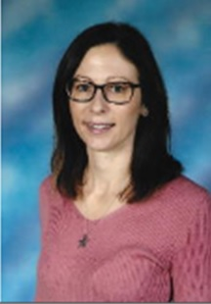
Mrs Morgan has two boys. She enjoys long walks with her little dog Henry and loves to exercise.

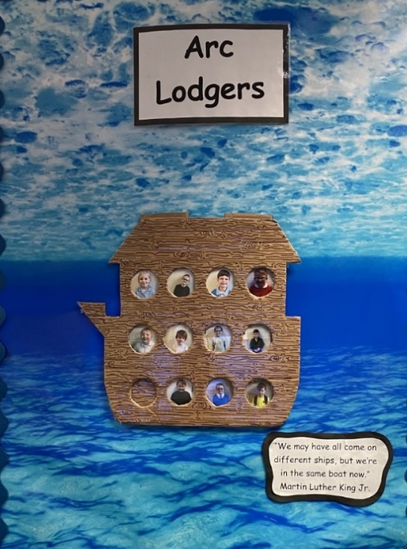
Arc Lodgers

At the Arc all our children are lodgers, which means that your stay will only be temporary. We are here to help you on your journey to find the right place for you.

Zones of Regulation
Following the Zones of Regulation helps us understand our emotions and our expected response. Sometimes you might not know how you feel, but don’t worry, it’s our job to help support you through those moments and guide you to make expected choices.
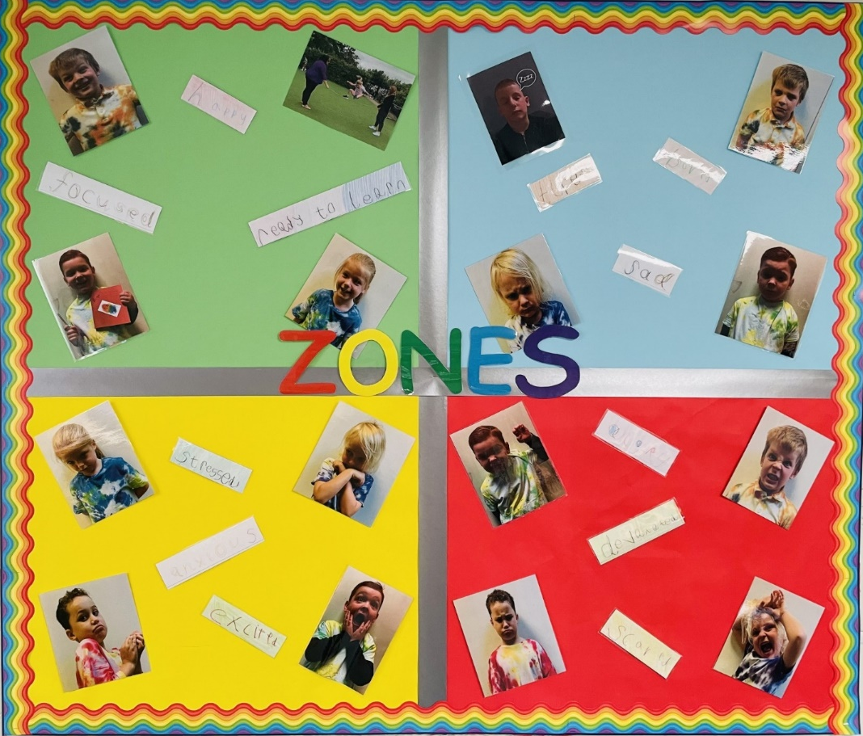

Here are some of our Arc lodgers showing us what their emotions look like to them.
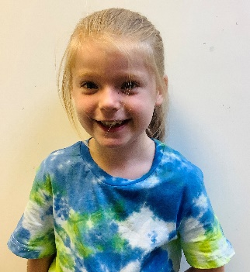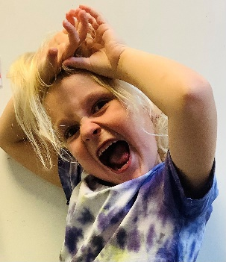
Happy Angry Scared Excited


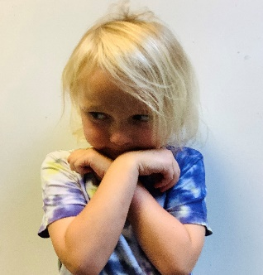


Sad Upset Nervous Confused

We want you to learn to be KIND to yourself and others. We want you feel like you BELONG and build CONNECTIONS with everyone. HOPE and COMPASSION will become part of your daily practice. This will help you, to learn and challenge yourself while staying focused.

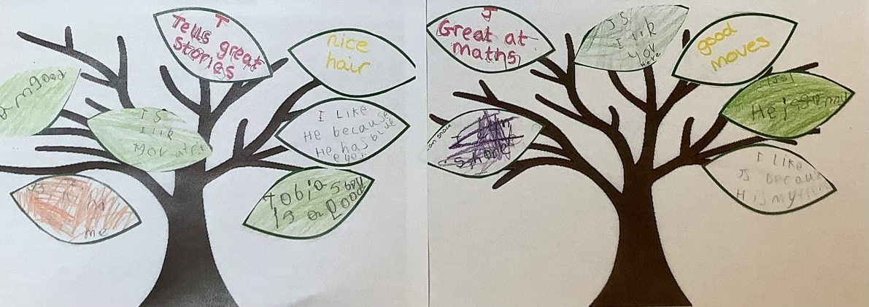

My Hidden Chimp
By Professor Steve Peters.
Our Hidden Chimp is a part of our brain. When we are dysregulated this part takes control, making decisions and acting without our permission. Using a ten-habit approach, The Hidden Chimp theory teaches children (and adults) strategies for taking control of their thoughts and decisions. Controlling their chimp allows children a sense of power while helping them manage their emotions and behaviour.
Habits include saying sorry, accepting ‘no’, talking about feelings and asking for help.
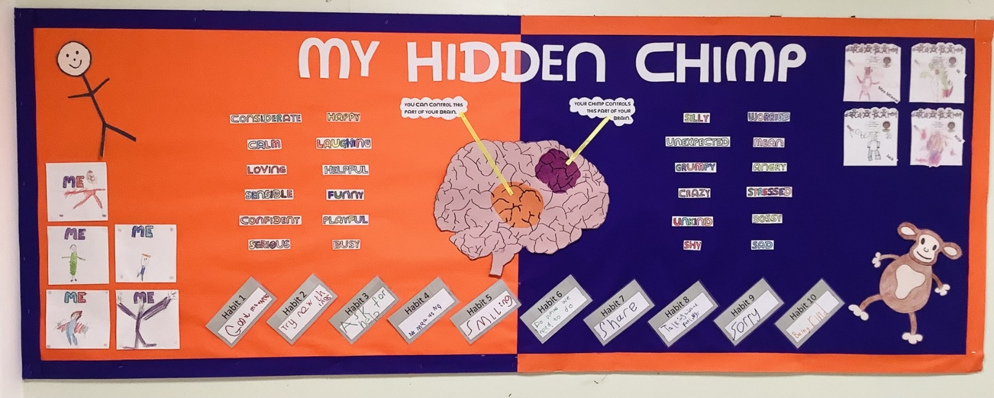

6 Core Strengths

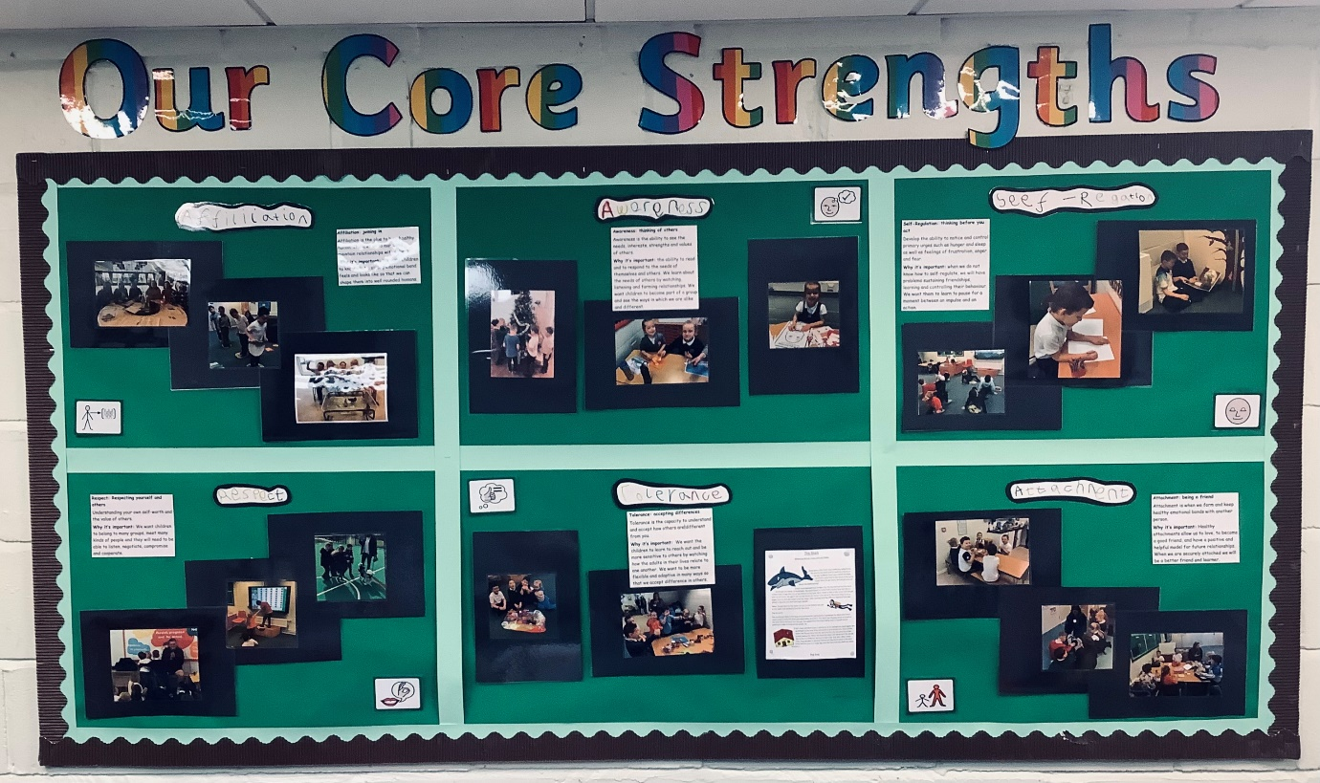

These are our 6 core strengths which we work on while we are in the Arc.
- Self- regulation
- Tolerance
- Affiliation
- Awareness
- Attachment
- Respect

These strengths help us grow to be the best version of ourselves.

The Arc
The Arc is situated within Ghyllgrove Primary School.
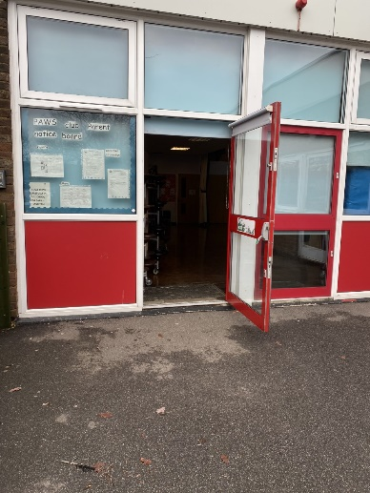
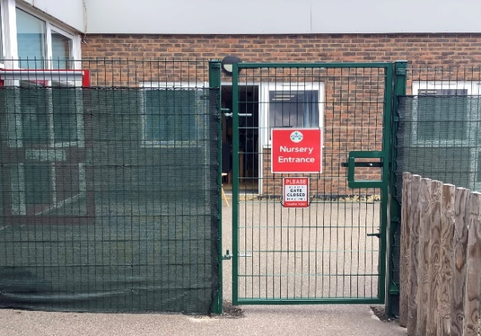
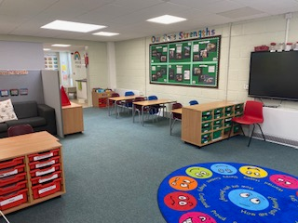
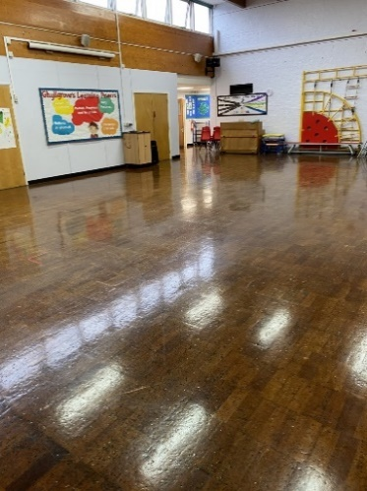
We will meet you at the Nursery Entrance gates and then go through the hall door. Our room is just off the hall. As you can see it’s a lovely safe space to learn and grow.
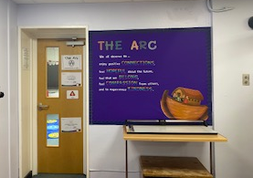

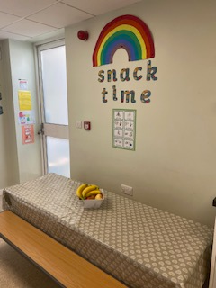
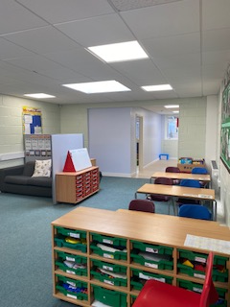

We have a separate calming room for those times when things get a bit too much and we need some time to ourselves.
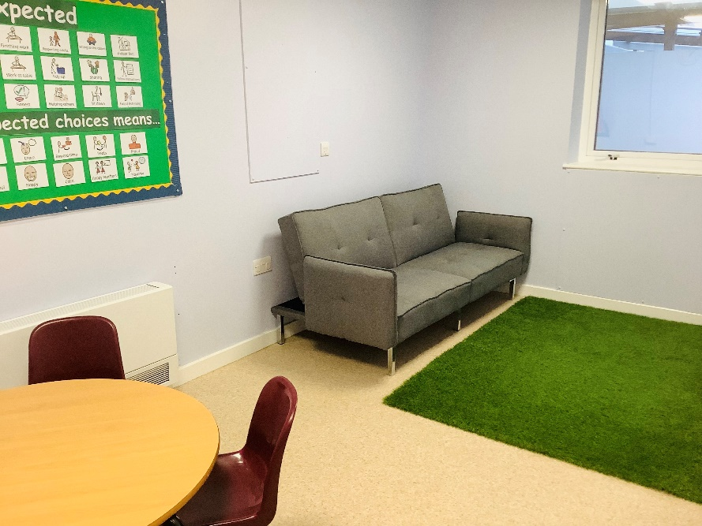
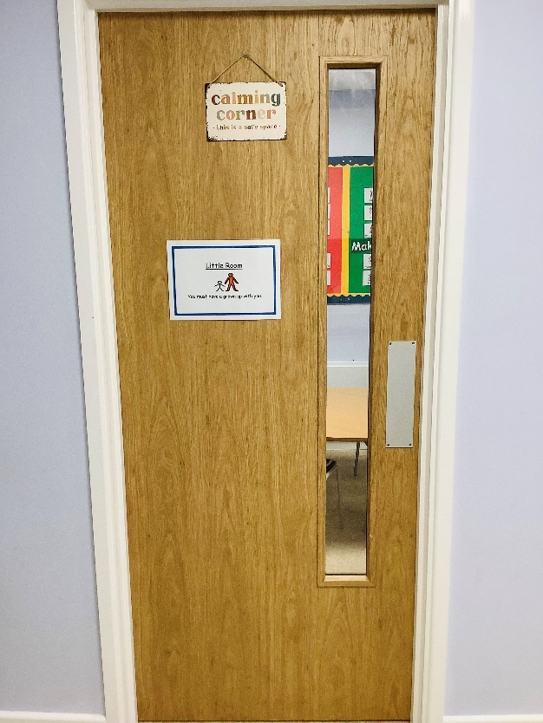

In the Arc we love Yoga. It helps with our excess energy, our breathing and it’s lots of fun!
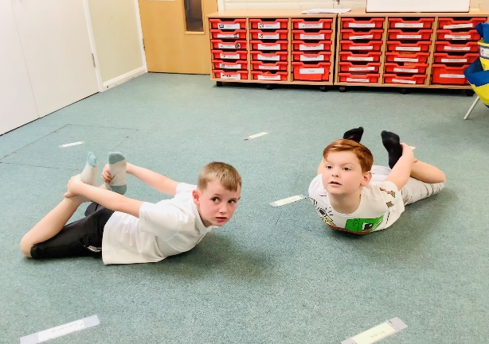
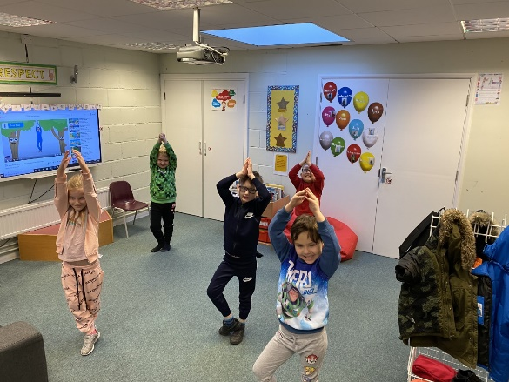
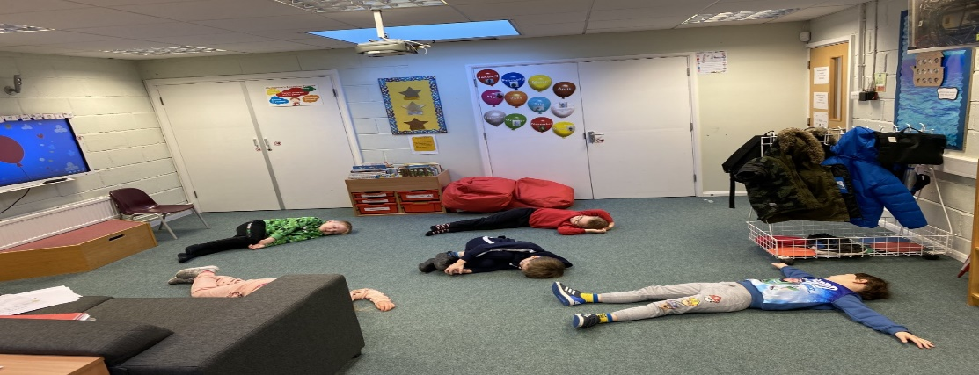
In the Arc we also try Mindfulness which helps to calm us.
Mindfulness helps us to regulate our breathing and can be used to help us focus.

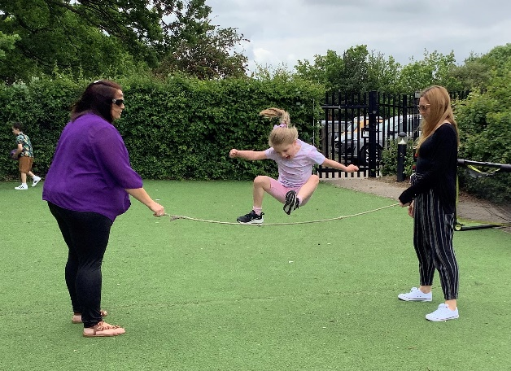
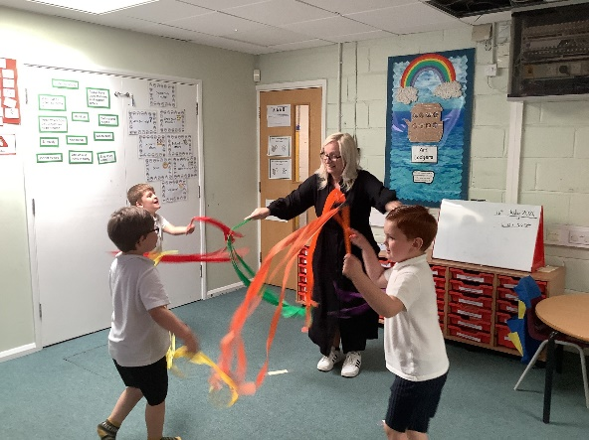
We love doing Gross Motor Skills & P.E. to help us keep both our minds and bodies healthy.

We love BOOKS in the Arc.
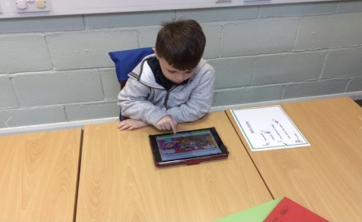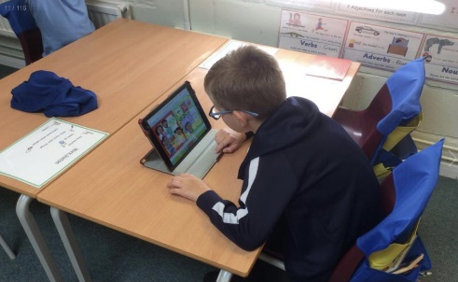

We read every day! Sometimes we like to read alone, other times sometimes we like to share books together.
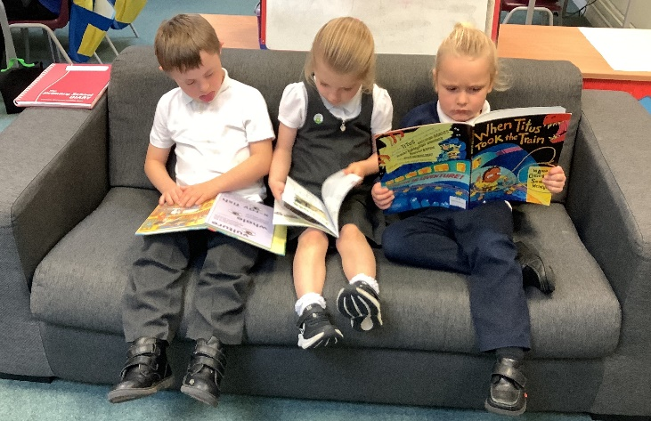
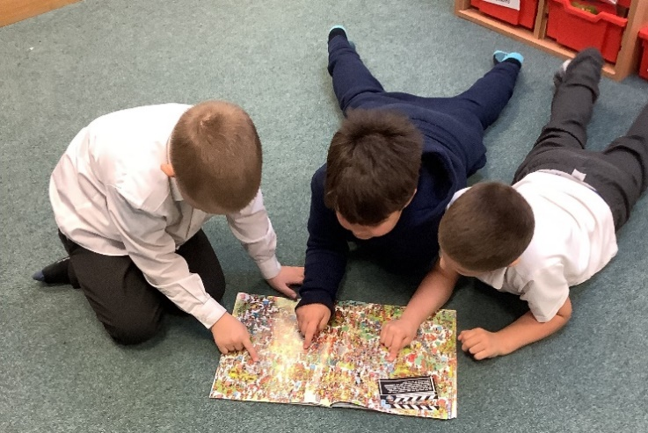

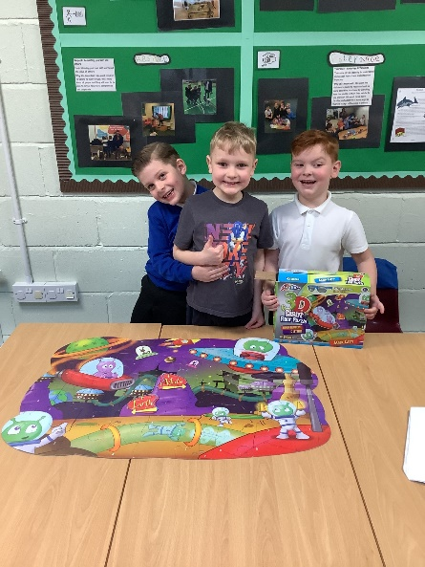
We are brilliant at sharing in the Arc! We learn to work together as a team.
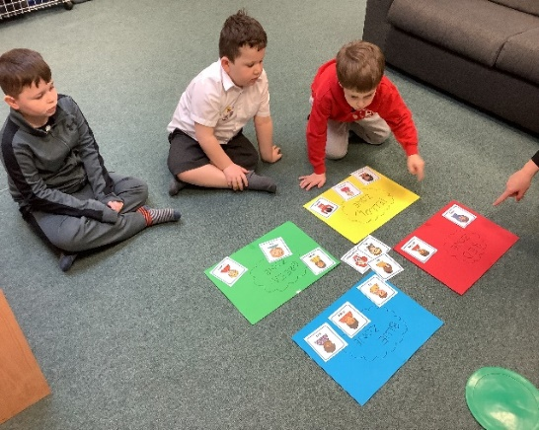
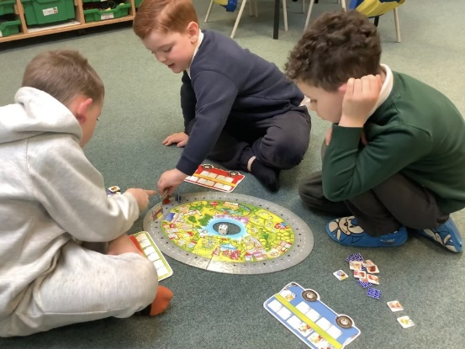

We enjoy Music & Animal Therapy
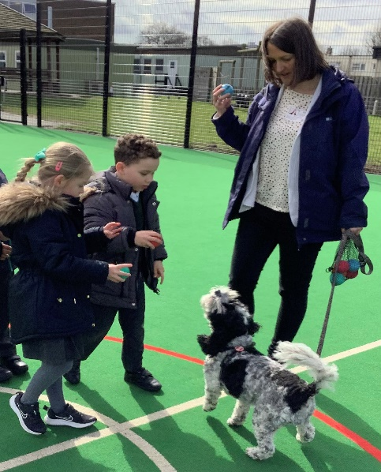
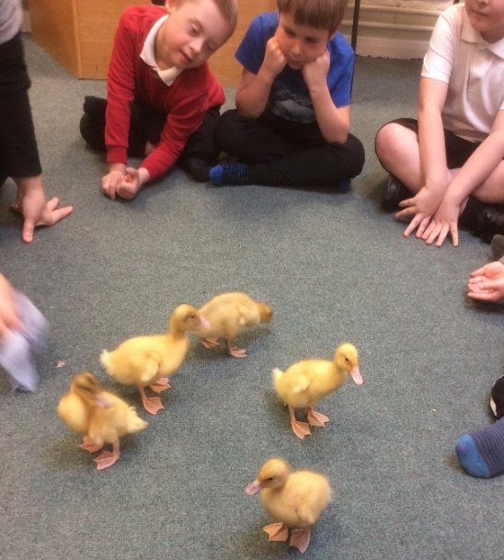

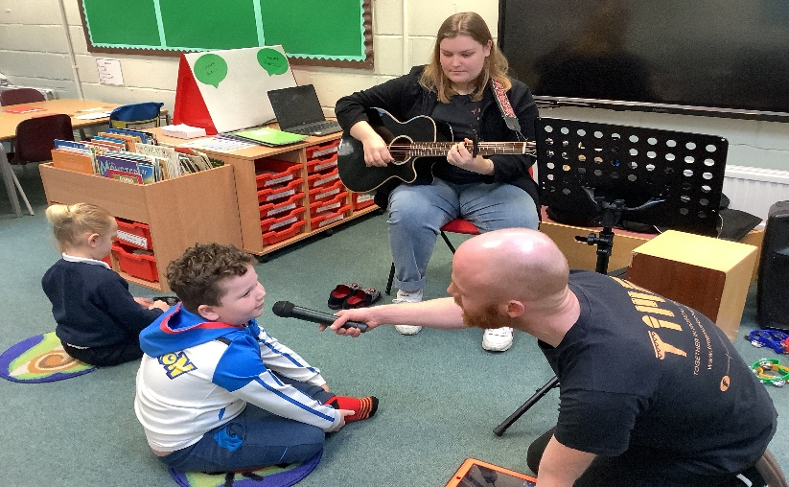

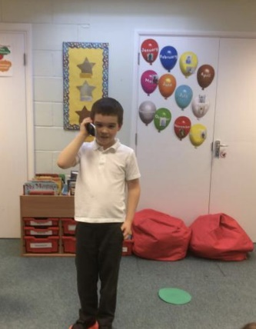
We teach Life Skills like:
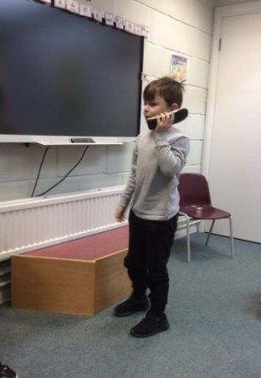
Answering the telephone.
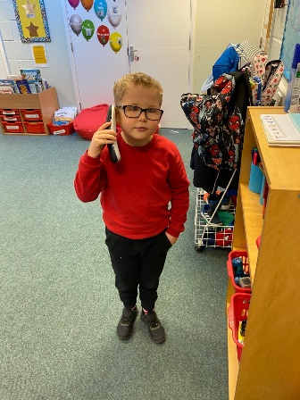

Making a snack, Cooking & washing up.
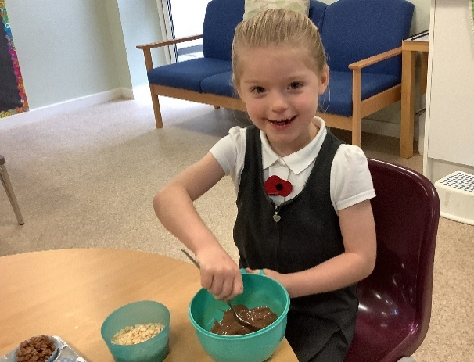

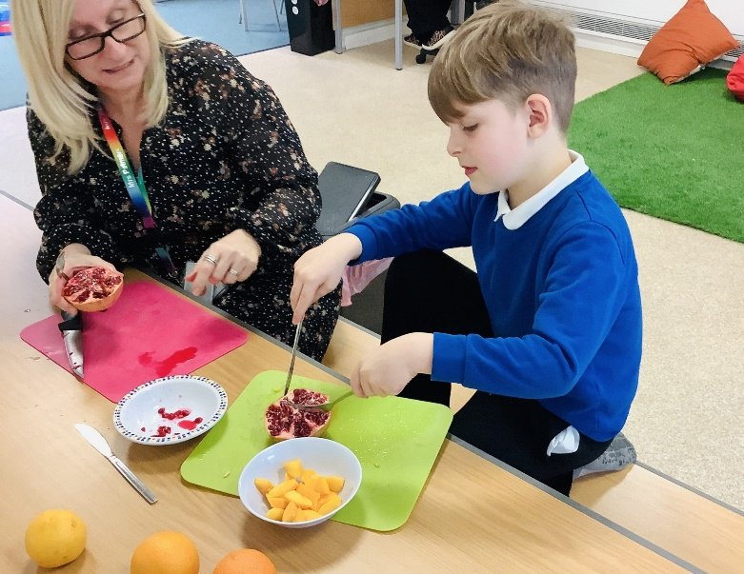
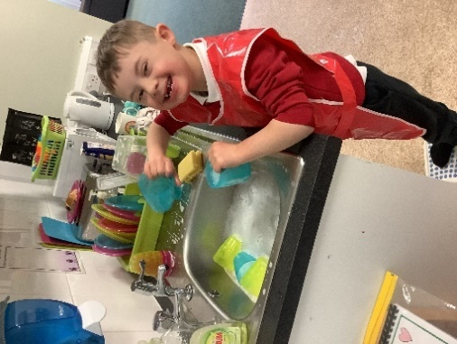

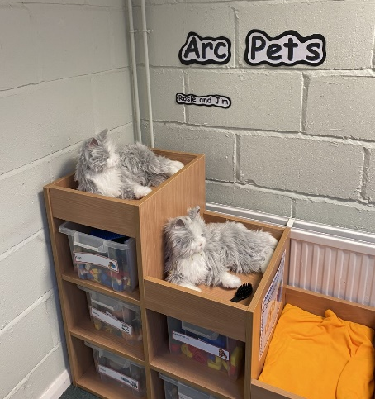

We have mechanical therapy cats in the Arc called Rosie and Jim who love to be brushed, stroked or read to. They even purr and roll over when they are fussed!

We know learning can be hard at times, so we try to make it fun and when we can’t we will make sure you are supported.
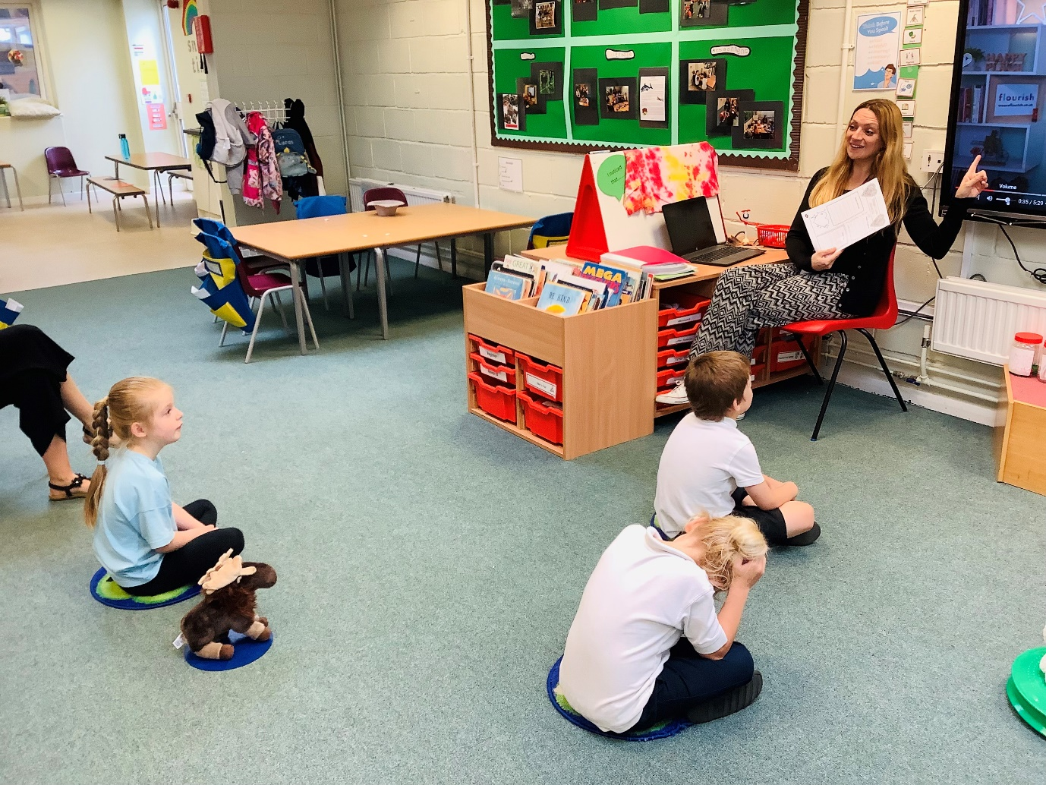
We are looking forward to welcoming you to The Arc!
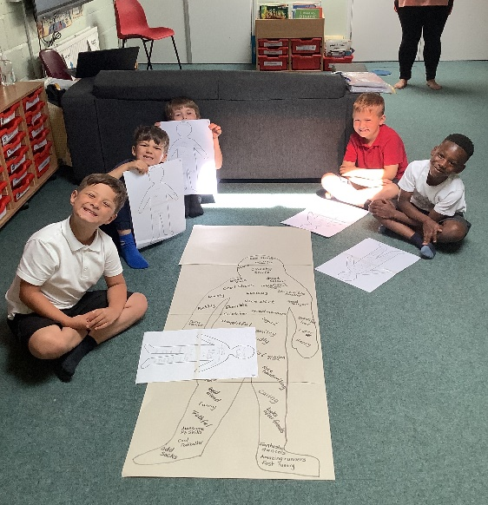
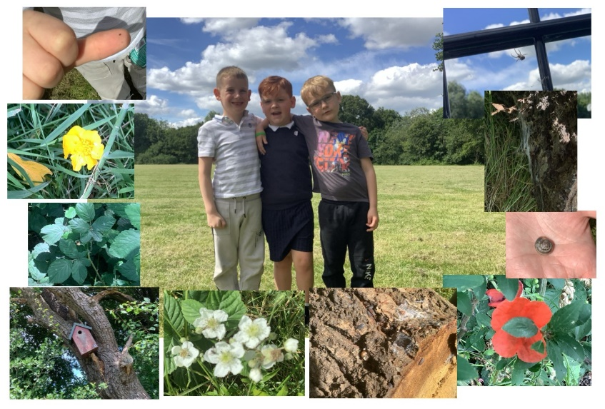

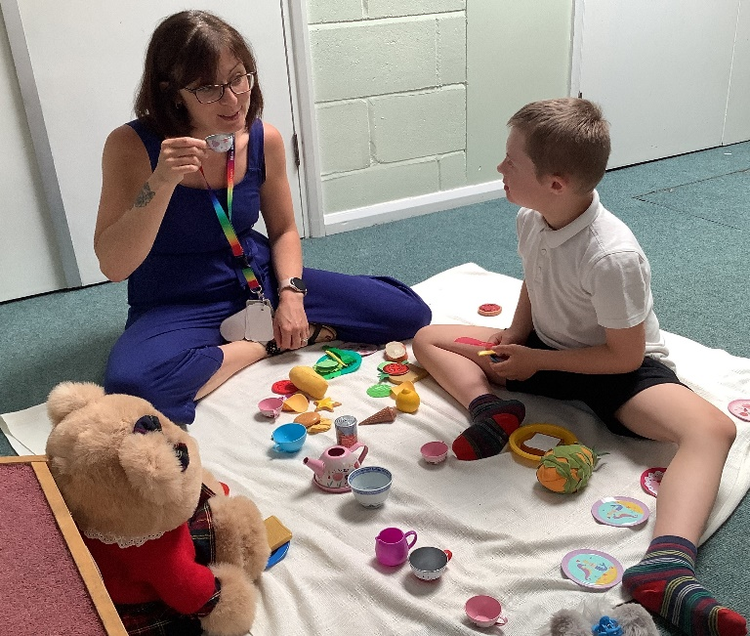
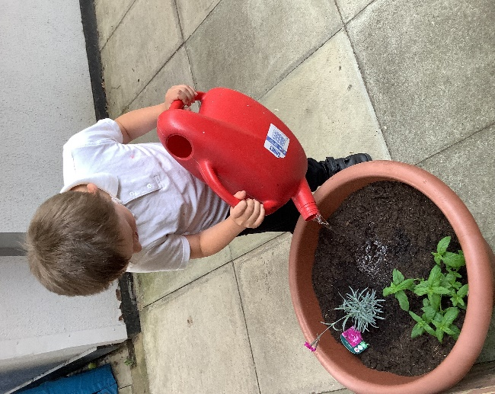
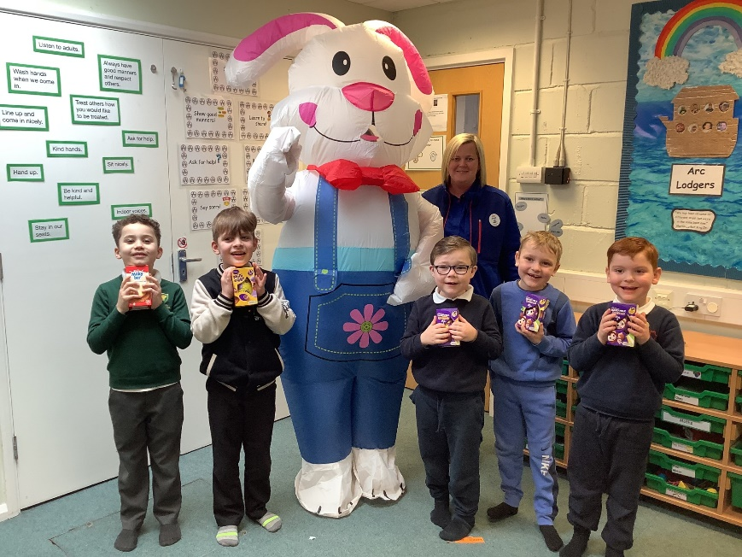
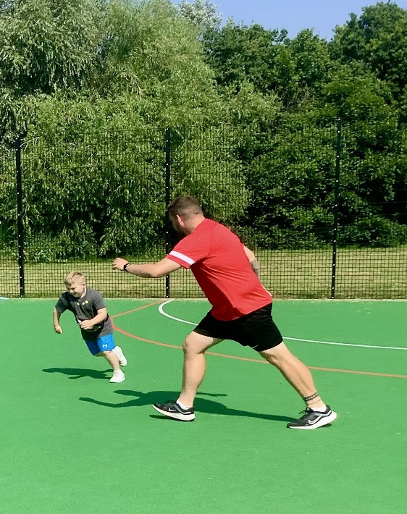
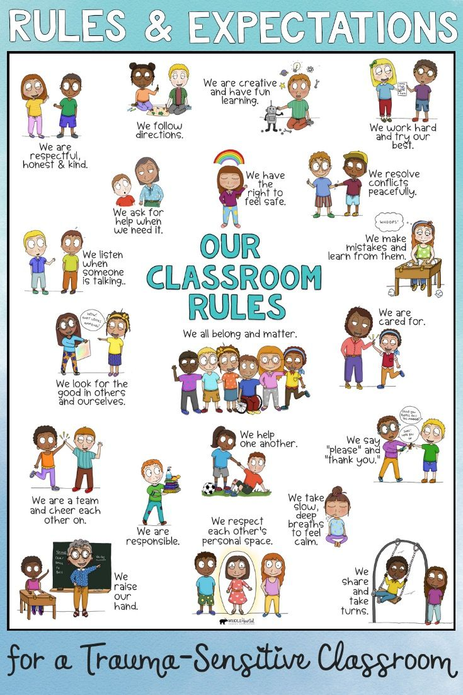
Kindness
Connection
Hope

Belonging
Compassion

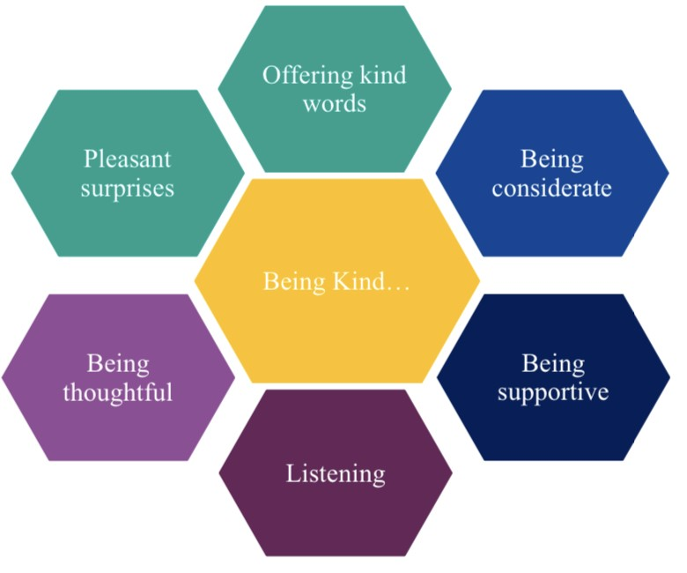

Contact Details

Head of Provision: Mrs Lisa Patmore
lisapatmore@ghyllgrove.essex.sch.uk

Family Support Worker: Mrs M Barwick
mbarwick@ghyllgrove.essex.sch.uk

Lead Arc Teaching Assistant: Miss S Yeo
syeo@ghyllgrove.essex.sch.uk

Address: Ghyllgrove Primary School
The Gore
Basildon, Essex
SS14 2BY

Contact Numbers:
Main Office: 01268 450067
Direct Line: 07538975146

