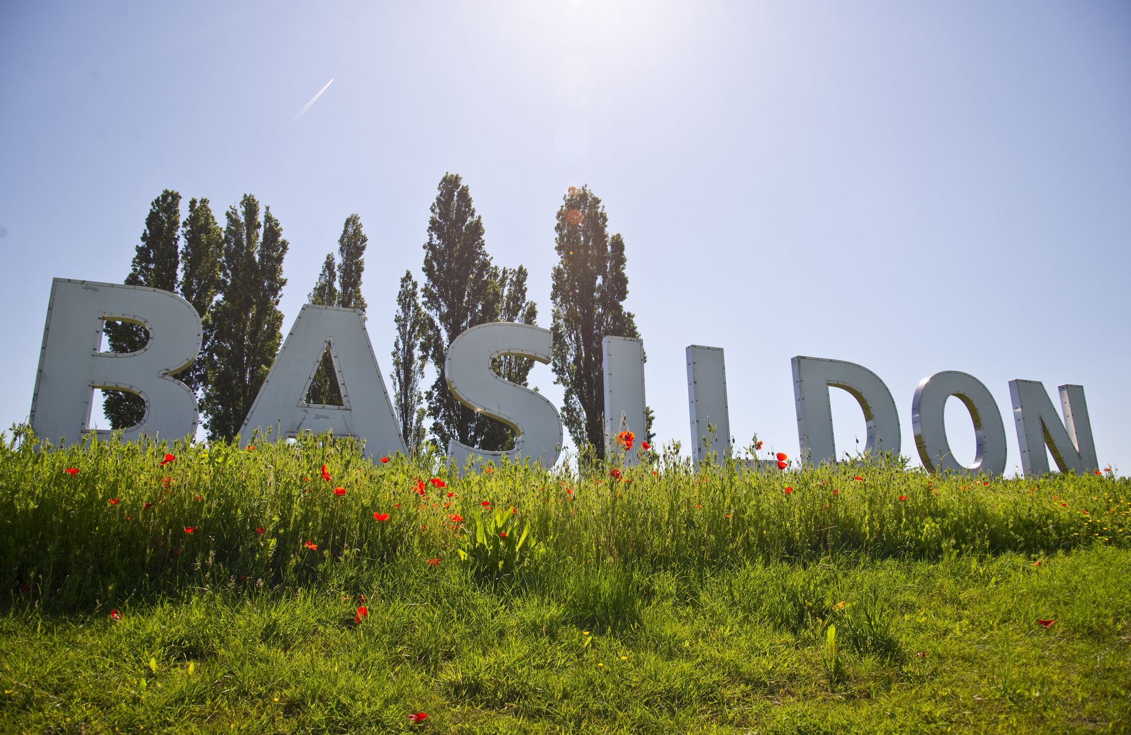
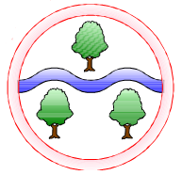
Where We Live – Exploring different types of vehicles old and modern.
Whatever The Weather – Studying the weather and how it changes through the seasons.

Mathematics
Place Value
Within 10
Within 20
Addition and Subtraction
Within 10
Within 20
Number bonds to 5 and 10
Geometry
2D and 3D shapes

Computing
Understanding technology around us
English
Reading
A selection of Fiction and Non-Fiction texts
Read Write Inc Phonics
Writing
Using full stops
Using capital letters
Finger spaces
Using ‘and’ to join two words
Pronoun ‘I’
Spelling
Year 1 Common Exception Words

Art
Autumn 2: drawing winter trees (with crayons)
Design and Technology
Autumn 2: design and make a mitten
History and Geography
Autumn 1:
Events Beyond Living Memory
Geography skills and map work for the local area
Autumn 2:
Human and physical geography
Weather and Seasons

Science
Autumn 2:
Seasonal Changes and recording weather including rainfall and temperature.

RE
How does a celebration bring people together? (Christianity and Islam)

Language of the Month
Sept: Lithuanian Oct: Polish
Nov: Turkish Dec: Romanian

Music
Listening and singing
Christmas music

PSHE
Autumn 1: Healthy Lifestyles
Autumn 2: Healthy Relationships

PE
Autumn 1: Games
Autumn 2: Dance/Yoga

Ghyllgrove Community Primary School
Year 1 Autumn

