Welcome to the Arc

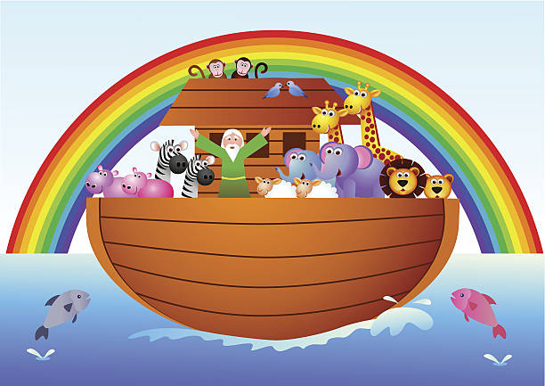

Meet the Staff
Head of Partnership Provision
Mrs. L Patmore

Mrs Patmore started the Arc. She is a mum of two and loves her holidays abroad. She enjoys reading and going to the gym. Mrs Patmore also has a very sweet tooth.
Family Support Worker
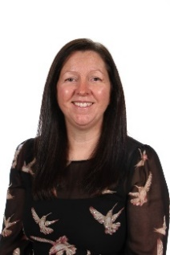
Mrs Michelle Barwick

Mrs Barwick has three grown up children. She loves long dog walks, making people smile and spending time with her family.
Partnership Provision Lead
Miss S Yeo

Miss Yeo has a teenage son. When she is not studying, she enjoys keeping a positive mindset and spending time by the sea.
Partnership Provision Specialist Teaching Assistants
Mrs L Morgan
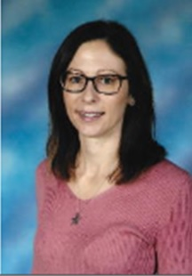
Mrs Morgan has two boys. She enjoys long walks with her little dog Henry and loves to exercise.

Mrs L Higgins
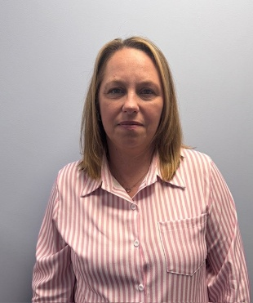
Mrs Higgins has four children and a grandson. She likes to dance and bake and loves her cat Bertie.

Miss F Bland

Miss Bland has two sons and two cats. She loves arts and crafts and going for afternoon tea.

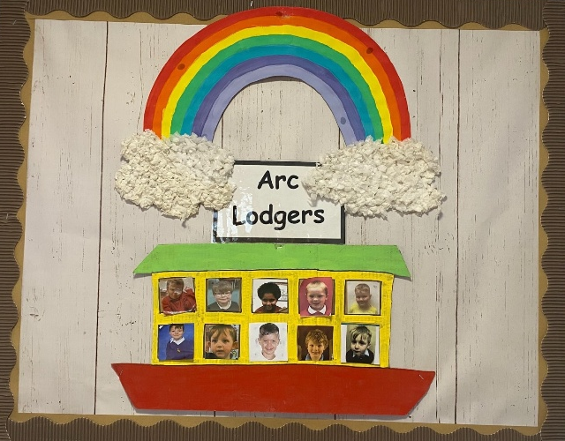
Arc Lodgers

At the Arc all our children are lodgers, which means that your stay will only be temporary. We are here to help you on your journey to find the right place for you.

Zones of Regulation
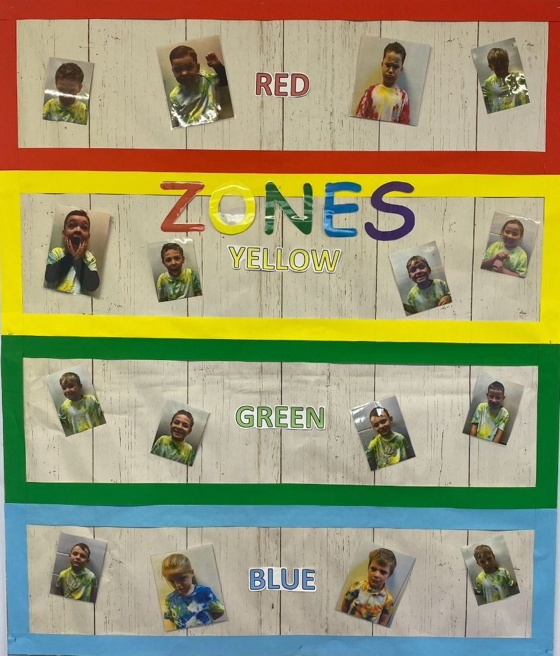
Following the Zones of Regulation helps us understand our emotions and our expected response. Sometimes you might not know how you feel, but don’t worry, it’s our job to help support you through those moments and guide you to make expected choices.

Here are some of our Arc lodgers showing us what their emotions look like to them.
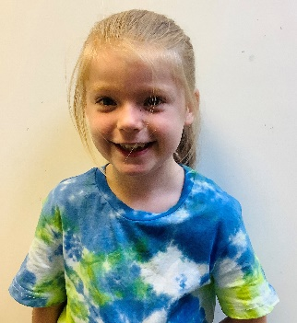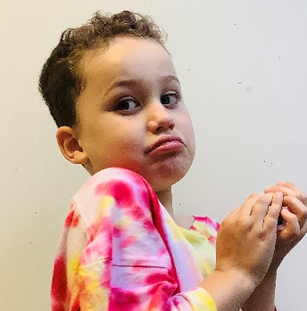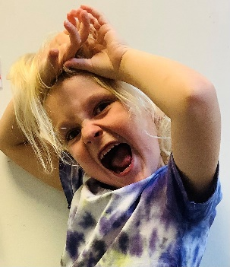
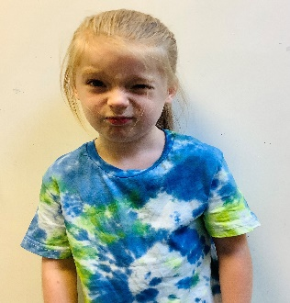

Happy Angry Scared Excited
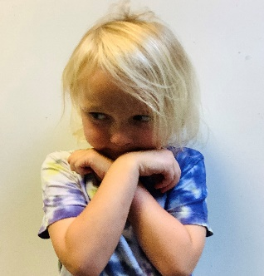


Sad Upset Nervous Confused

We want you to learn to be KIND to yourself and others. We want you feel like you BELONG and build CONNECTIONS with everyone. HOPE and COMPASSION will become part of your daily practice. This will help you, to learn and challenge yourself while staying focused.
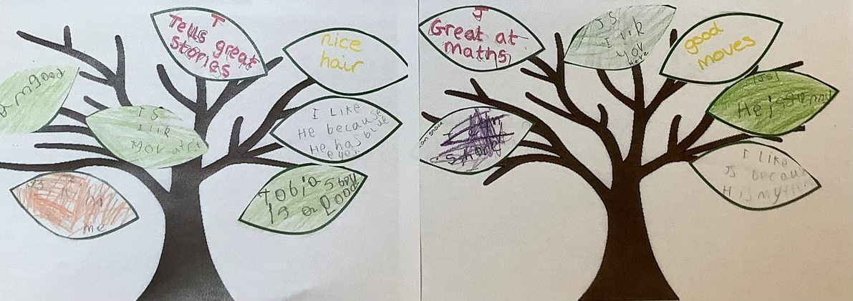

My Hidden Chimp
By Professor Steve Peters.
Our Hidden Chimp is a part of our brain. When we are dysregulated this part takes control, making decisions and acting without our permission. Using a ten-habit approach, The Hidden Chimp theory teaches children (and adults) strategies for taking control of their thoughts and decisions. Controlling their chimp allows children a sense of power while helping them manage their emotions and behaviour.
Habits include saying sorry, accepting ‘no’, talking about feelings and asking for help.
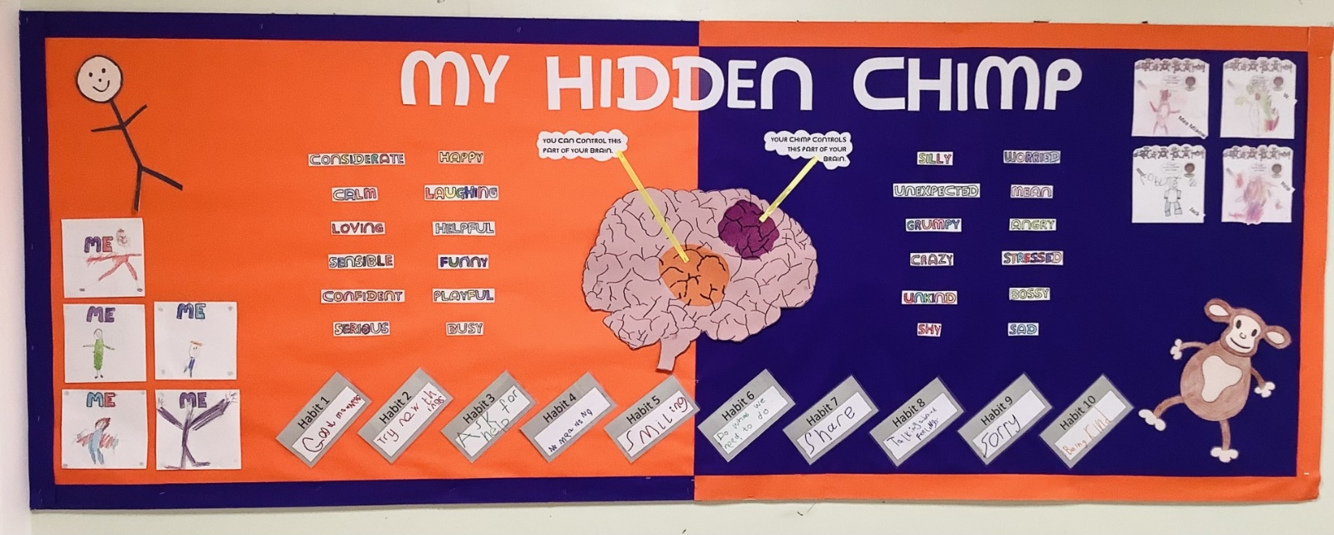

6 Core Strengths

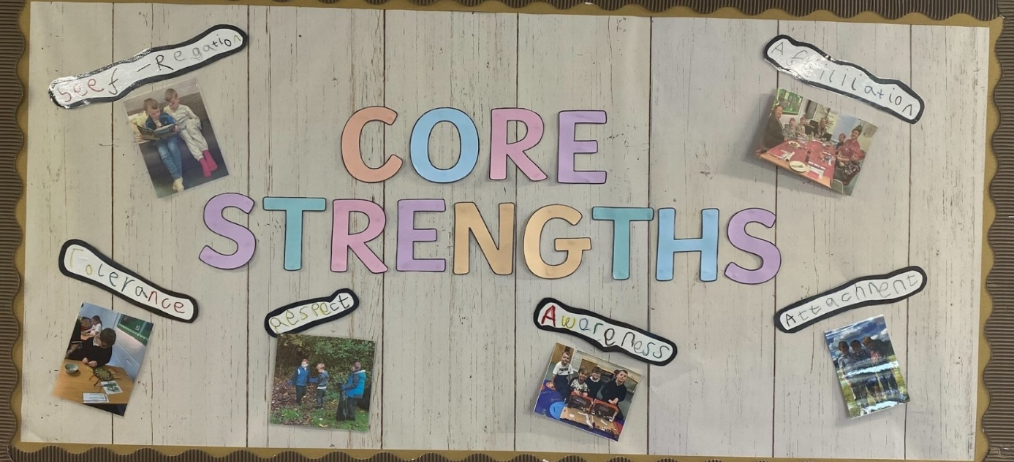

These are our 6 core strengths which we work on while we are in the Arc.
- Self- regulation
- Tolerance
- Affiliation
- Awareness
- Attachment
- Respect

These strengths help us grow to be the best version of ourselves.

The Arc
The Arc is situated within Ghyllgrove Primary School.
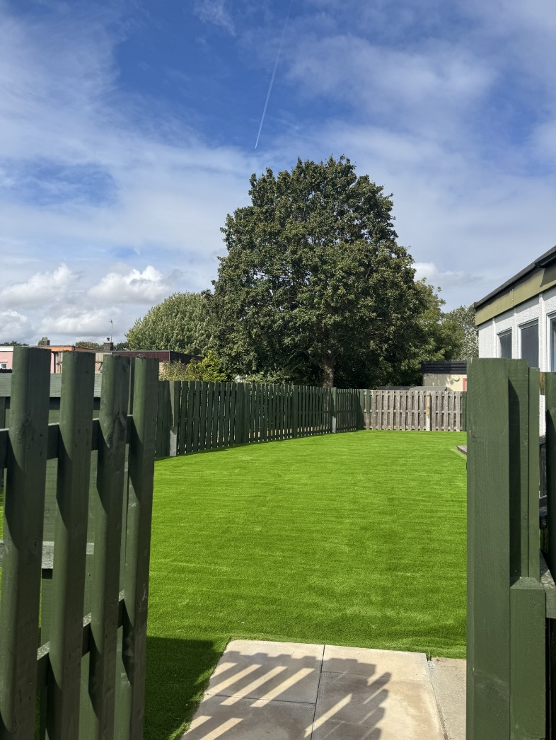
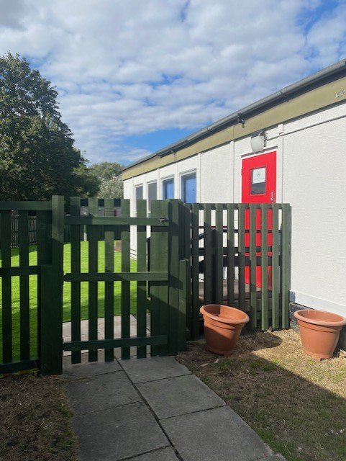
We will meet you at the Dewland Entrance gates and then go to The Arc gates and into our lovely garden.

This is The Arc entrance…

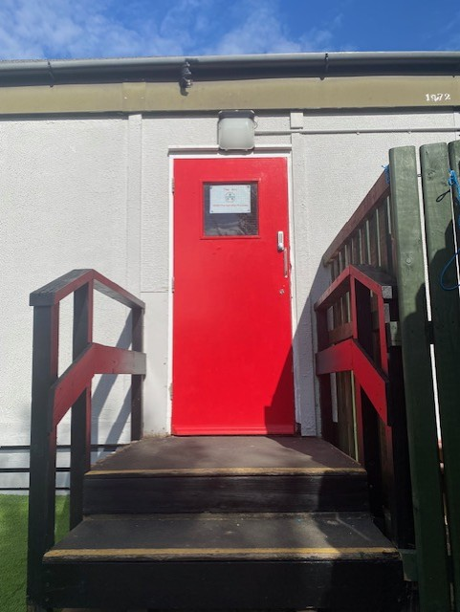
We have four section inside The Arc…
Home room – for when we need some peace and quiet.
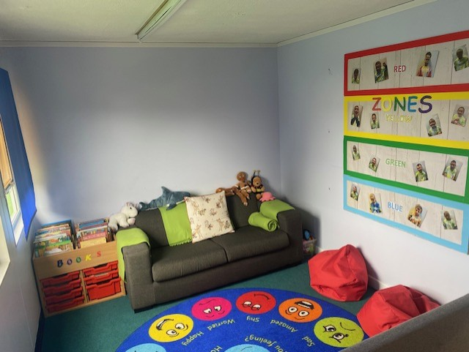

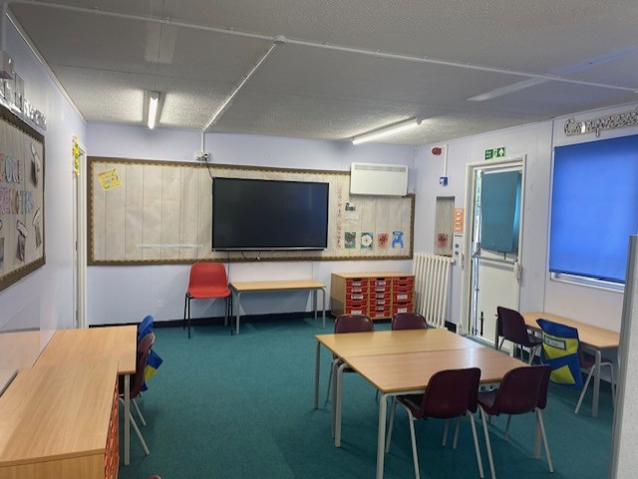
Learning room – where do our lessons.

Kitchen area – for lunch and snack.
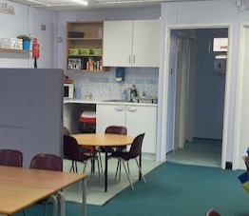

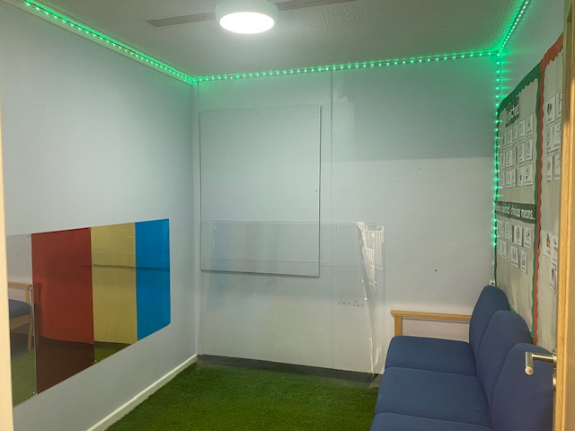
And the Little room – for when things feel a little too much and we need somewhere to regulate our emotions.

In the Arc we love Yoga. It helps with our excess energy, our breathing and it’s lots of fun!
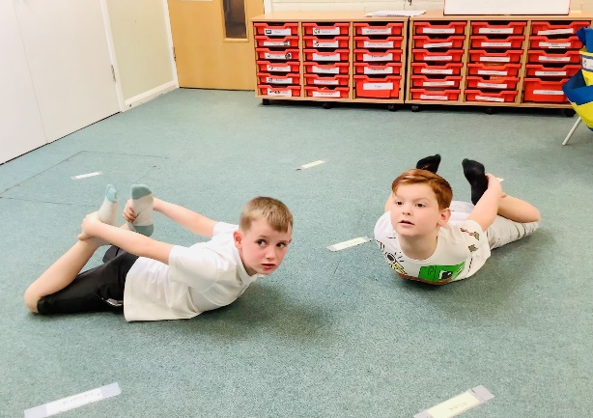
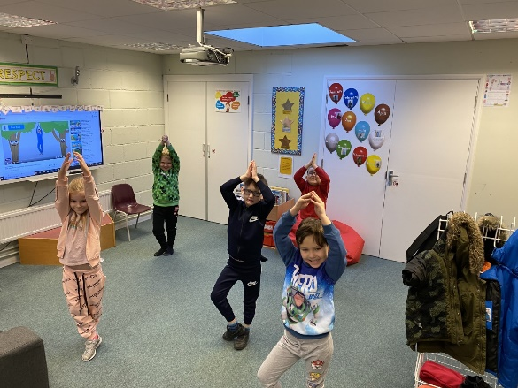
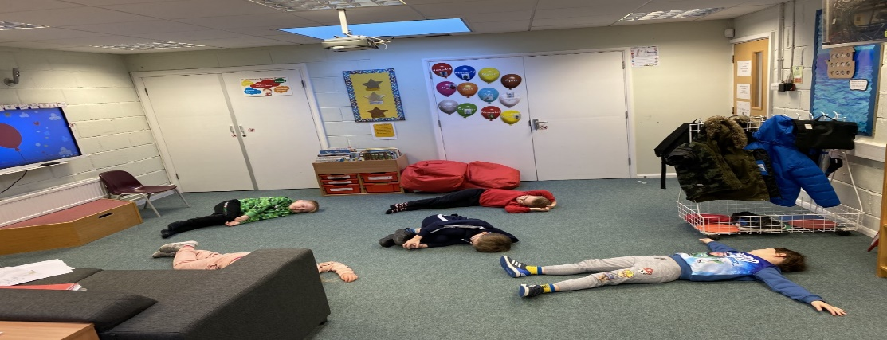
In the Arc we also try Mindfulness which helps to calm us.
Mindfulness helps us to regulate our breathing and can be used to help us focus.

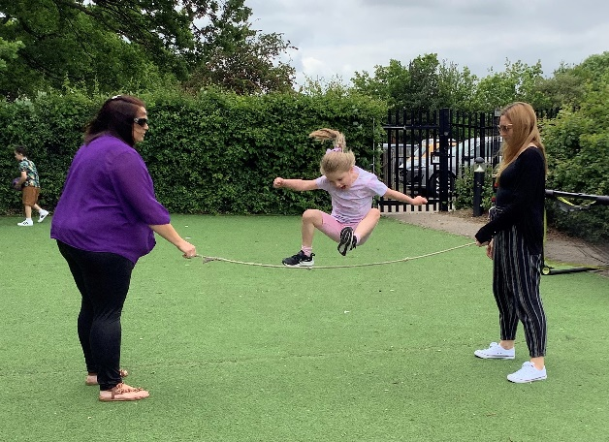
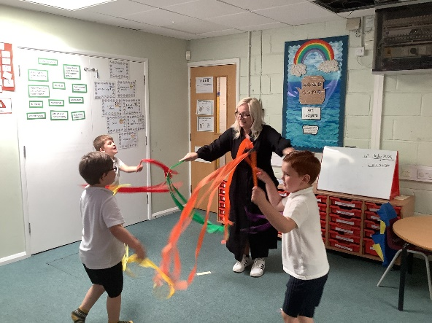
We love doing Gross Motor Skills & P.E. to help us keep both our minds and bodies healthy.

We love BOOKS in the Arc.
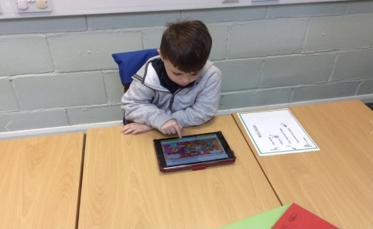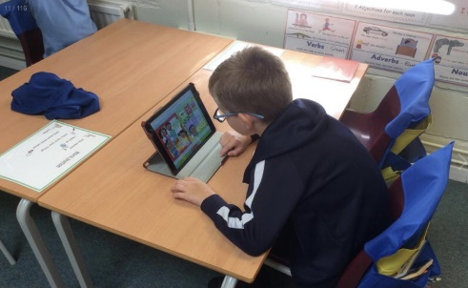

We read every day! Sometimes we like to read alone, other times sometimes we like to share books together.
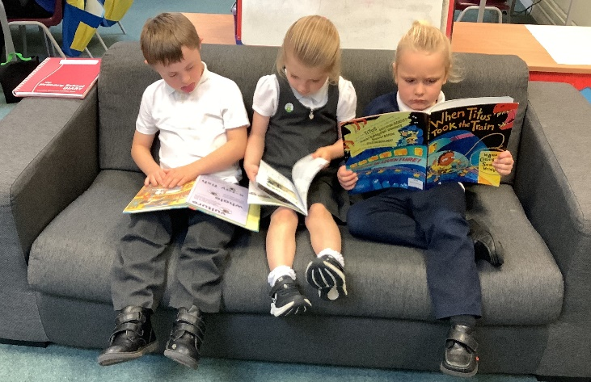
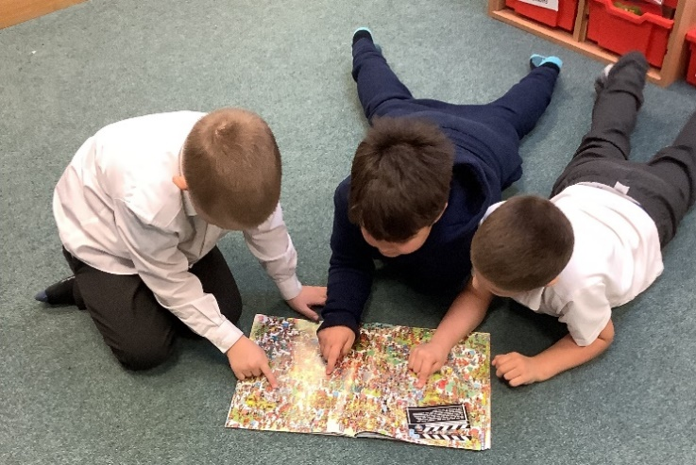

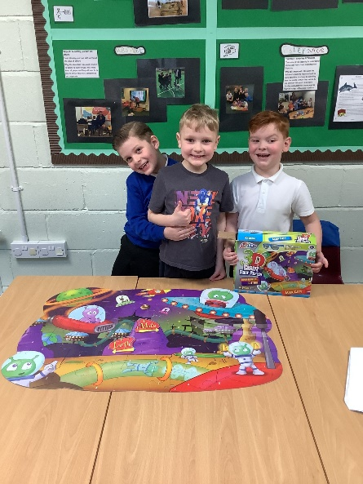
We are brilliant at sharing in the Arc! We learn to work together as a team.
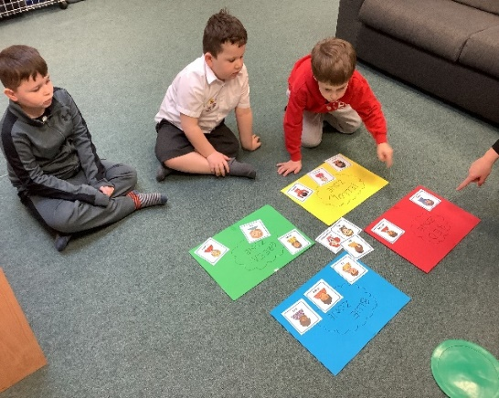
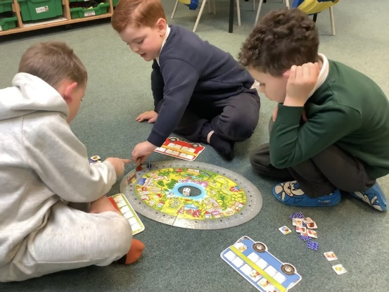

We enjoy Music & Animal Therapy
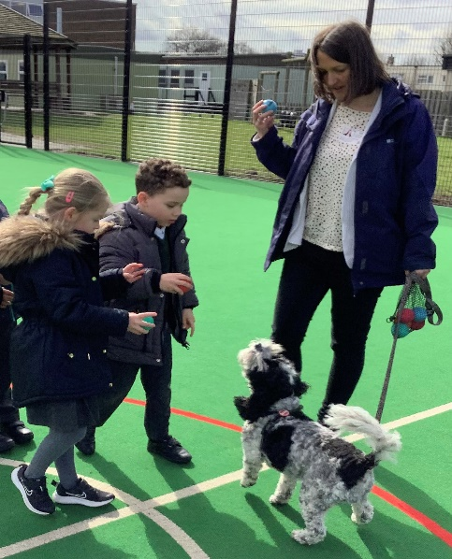
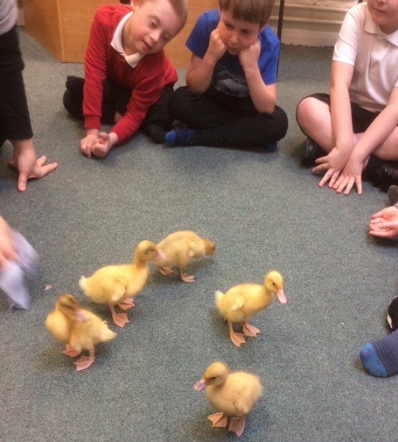

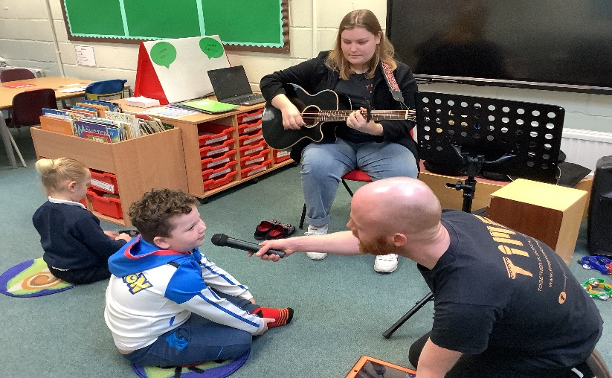

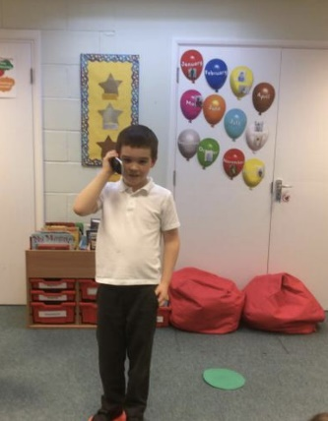
We teach Life Skills like:
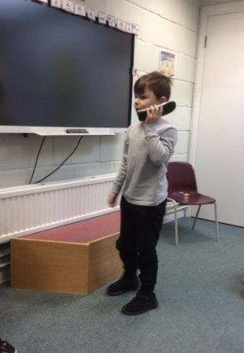
Answering the telephone.
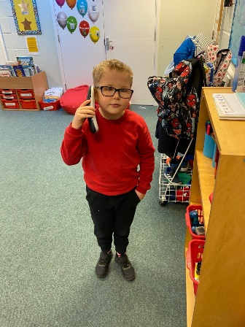

Making a snack, Cooking & washing up.
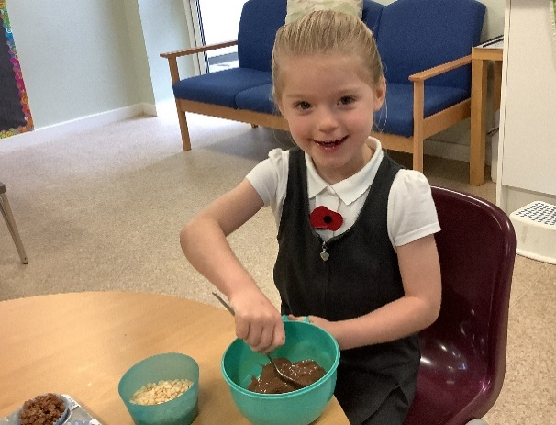

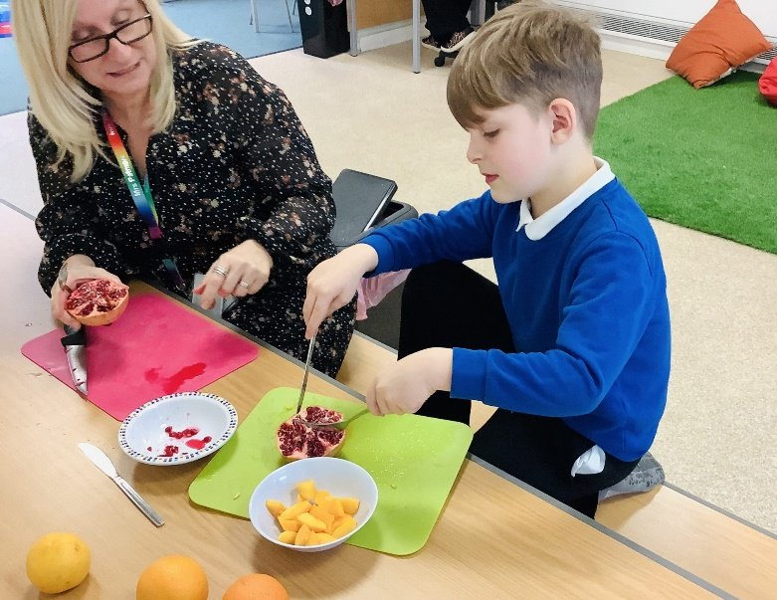
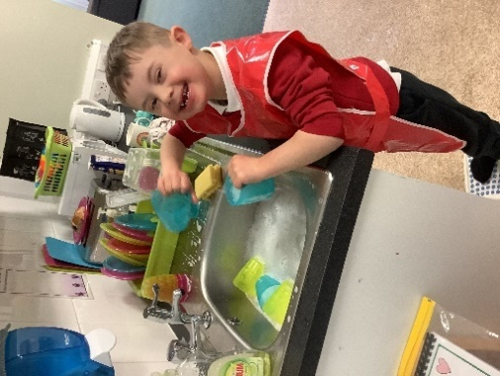

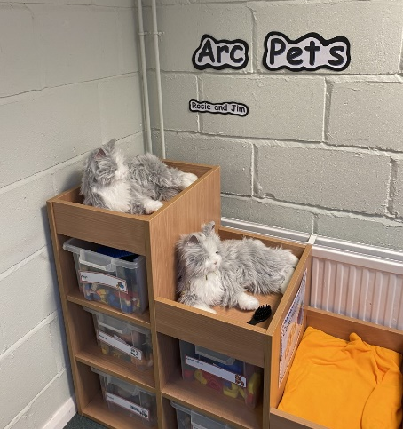

We have mechanical therapy cats in the Arc called Rosie and Jim who love to be brushed, stroked or read to. They even purr and roll over when they are fussed!

We know learning can be hard at times, so we try to make it fun and when we can’t we will make sure you are supported.
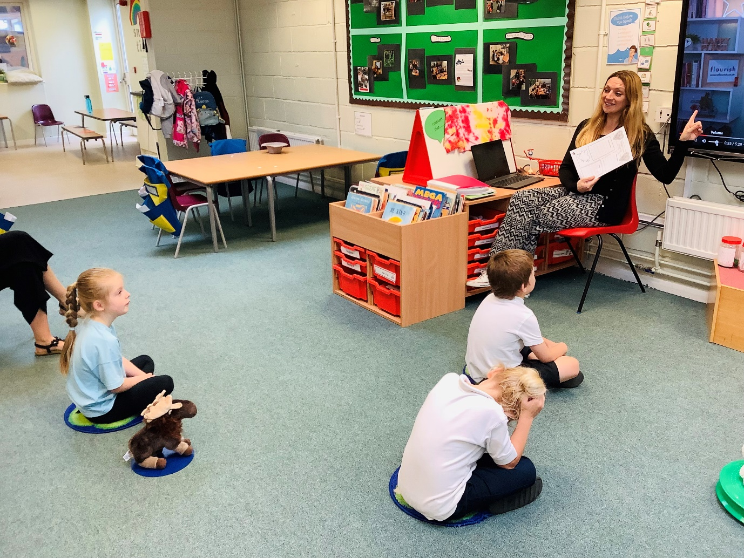
We are looking forward to welcoming you to The Arc!
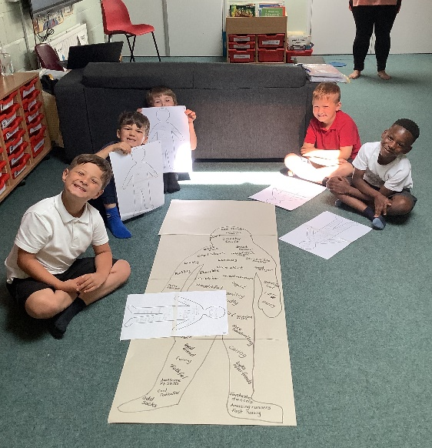
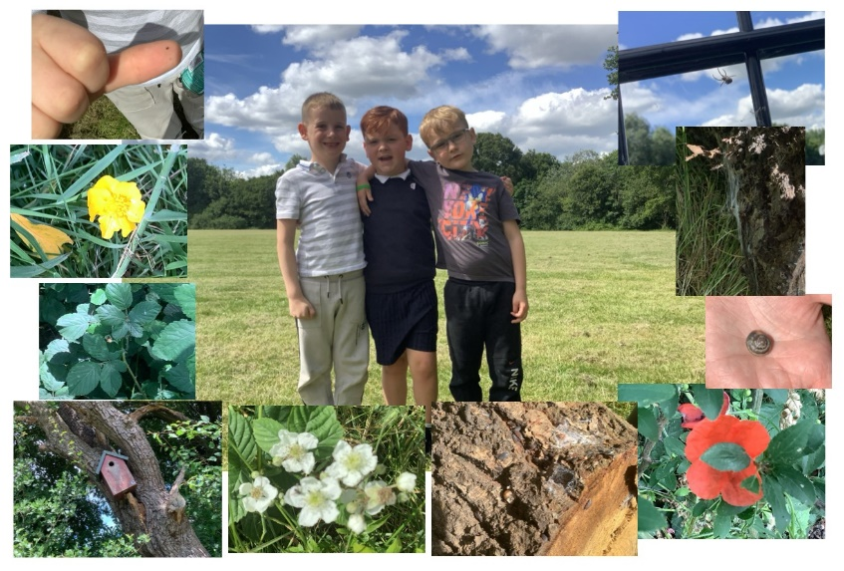

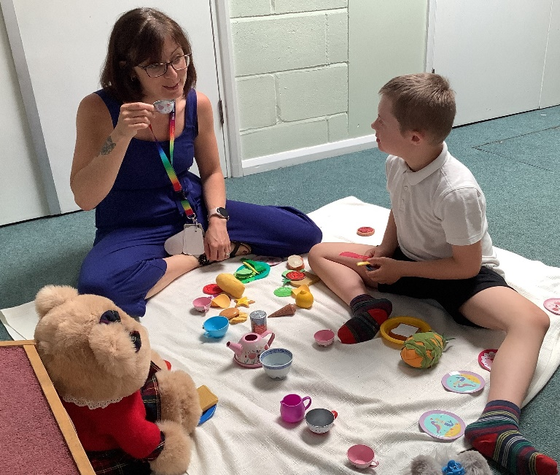
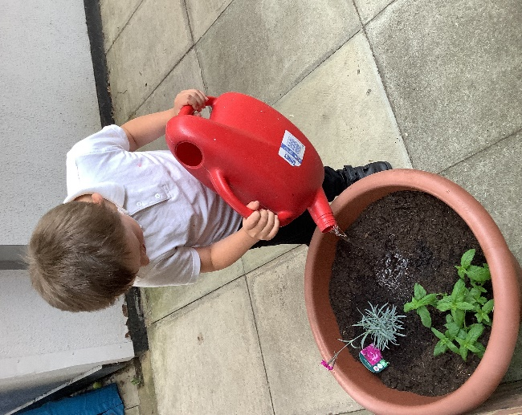
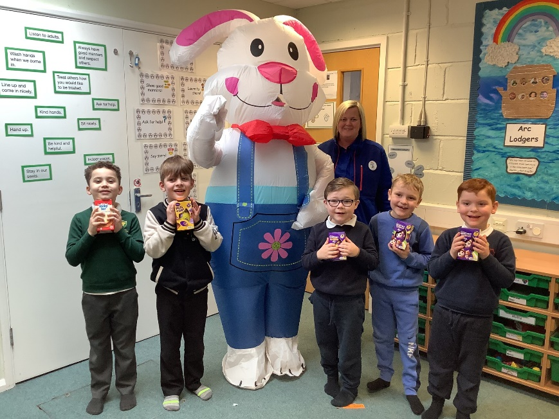
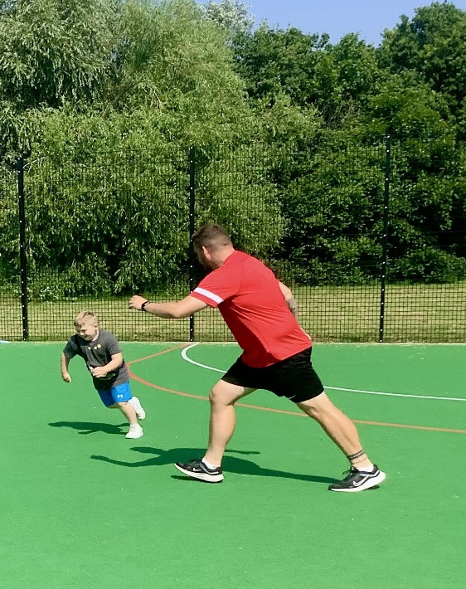
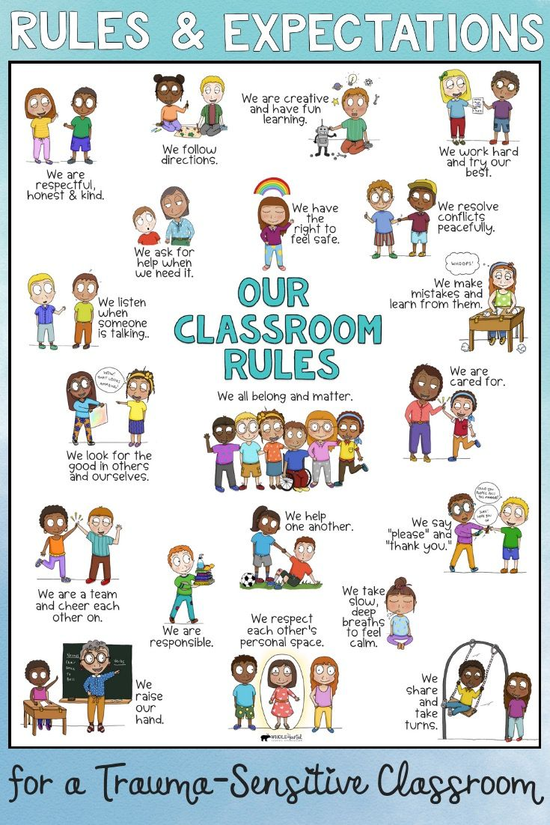
Kindness
Connection
Hope

Belonging
Compassion

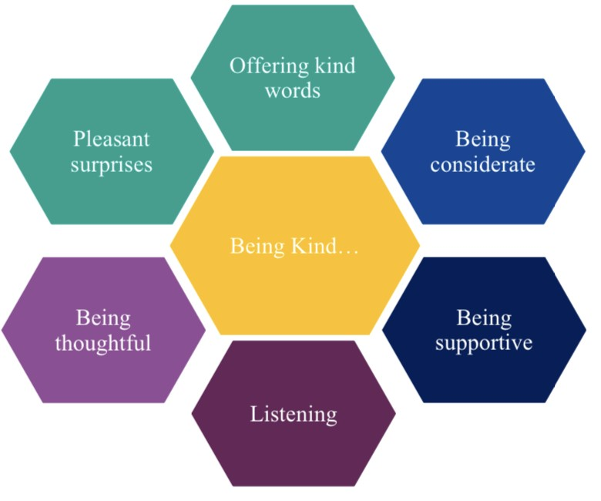

Contact Details

Head of Partnership Provision: Mrs Lisa Patmore
lisapatmore@ghyllgrove.essex.sch.uk

Family Support Worker: Mrs M Barwick
mbarwick@ghyllgrove.essex.sch.uk

Provision Lead: Miss S Yeo
syeo@ghyllgrove.essex.sch.uk

Address: Ghyllgrove Primary School
The Gore
Basildon, Essex
SS14 2BY

Contact Numbers:
Main Office: 01268 450067
Direct Line: 07538975146

