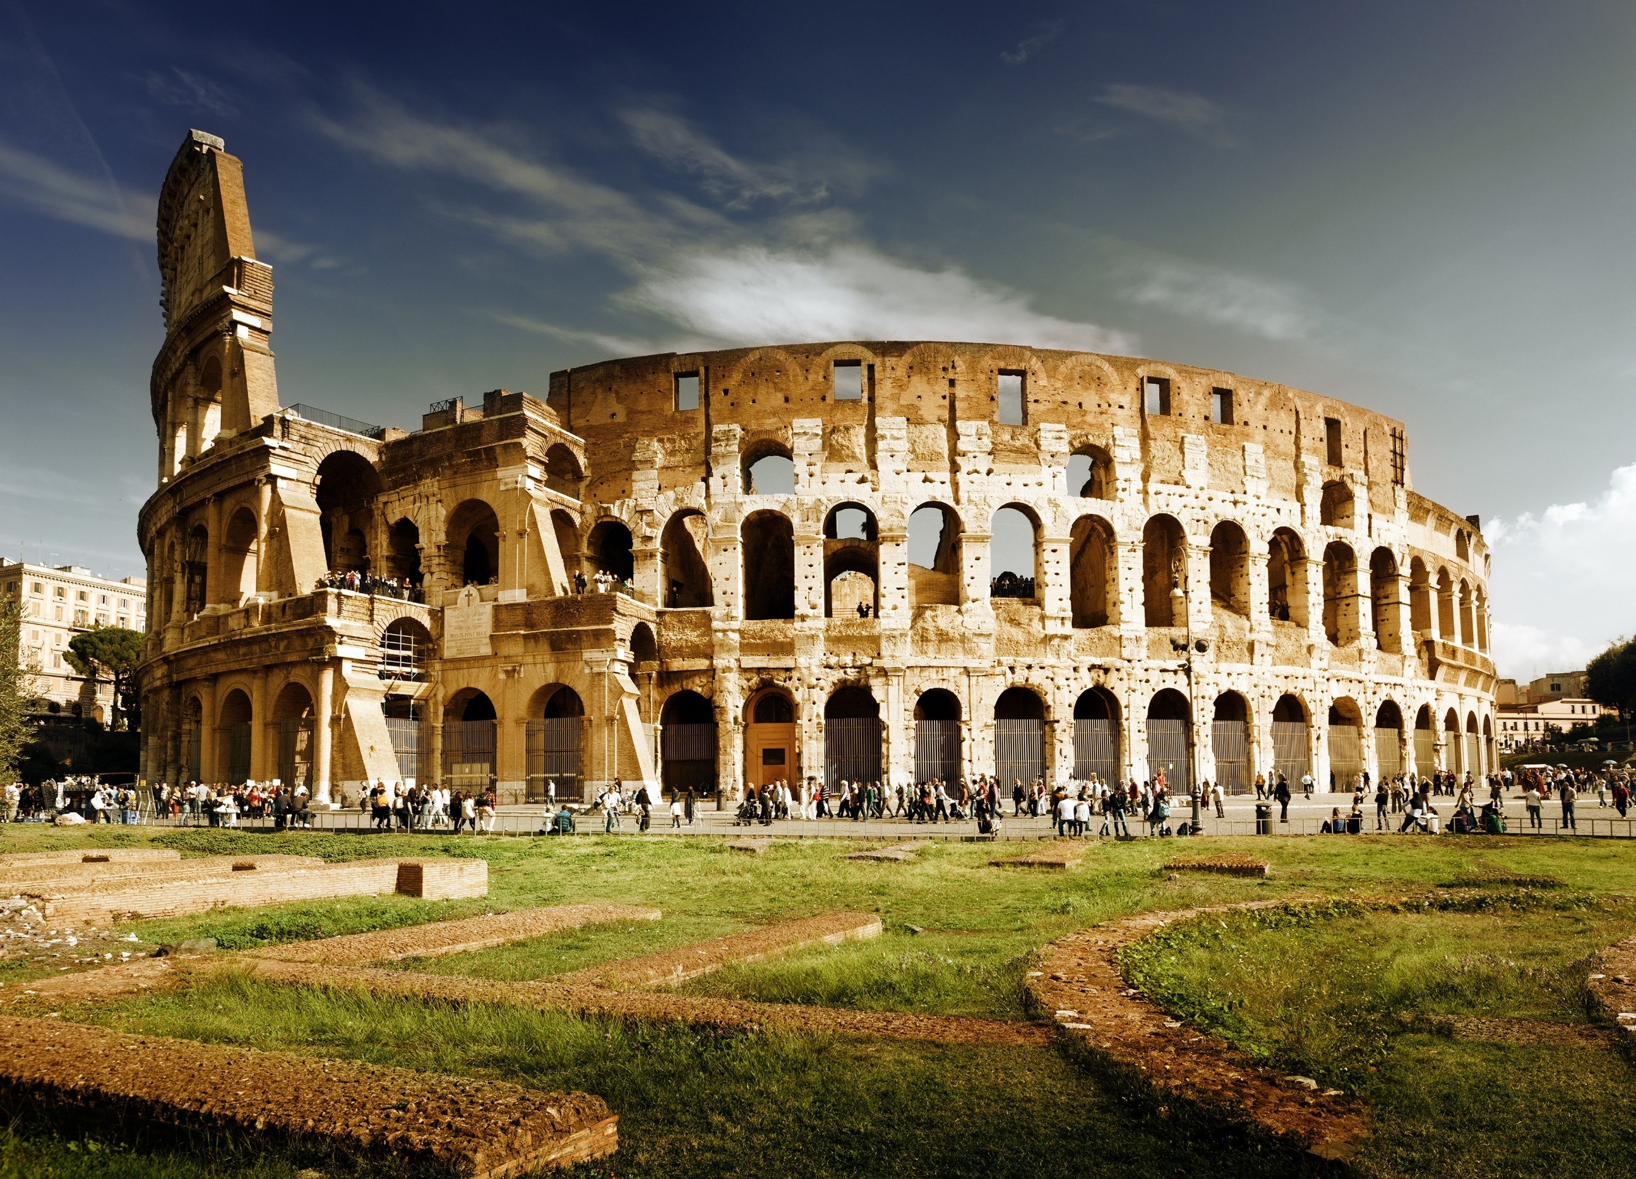
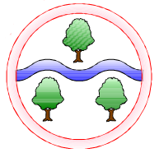
PSHE
Families and friendships
Respectful relationships
Healthy lifestyles
Feelings and emotions
Computing
Understanding Technology: The Internet
E-Safety: Rings of responsibility / Passwords
PE
Swimming
Fitness
Dance
Tennis
Art
Drawing and sketching: Storytelling through drawing
The Iron Man
Design and Technology
Electrical circuits
Light up Christmas cards
Music
Adapting and transposing motifs (Romans)
RE
Where do religious beliefs come from?
What do we mean by truth – Is seeing believing?
Languages
Portraits
Describing in French
Mathematics
Read and write numbers in digits and words
Recognise and represent numbers in different ways
Understand place value in numbers to 10,000
Compare and order numbers
Rounding numbers
Find 1, 10, 100 and 1000 more/less
Add and subtract multiples of 1, 10, 100 and 1000 mentally
Add and subtract 4-digit numbers using column method
6, 7, 12 times tables multiplication & division facts
Area and perimeter
Length
English
The Iron Man

Character descriptions
Setting descriptions Persuasive letters
Diary entries
Narrative writing
Poetry

Expanded noun phrases using adjectives and prepositions
Conjunctions
Verb and adverb pairs
Adverbs for cohesions
Paragraphing
Standard English and tenses
Interesting vocabulary
Topics
Autumn 1: The Romans
Autumn 2: Mad Scientists
History and Geography
A study of the Roman Empire and its impact on Britain
The Roman Empire
Comparing Celts and Romans
Roman invasions
Life in the Roman army
Boudica’s revolts
Life in Roman Colchester
The Roman’s legacy
Chronological order
Exploring sources
Water and the water cycle
Science
States of matter: Solids, liquids and gases
Reversible and irreversible changes
Heating and cooling materials
Evaporation and condensation
Scientific investigation skills:
Asking questions, making predictions, comparing and presenting findings, drawing conclusions

Ghyllgrove Community Primary School
Year 4 Autumn

