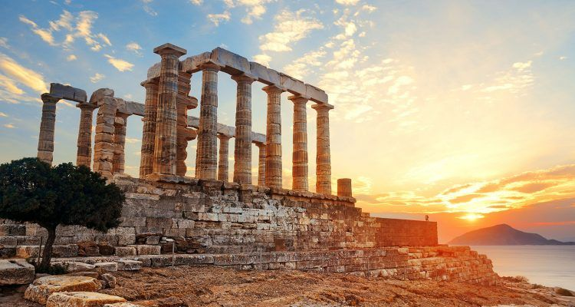
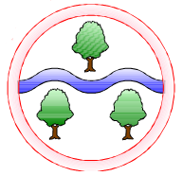
Music
Composition Notation
Mathematics
Place Value
up to one million
Addition and subtraction numbers up to four digits
Multiplication and Division
Multiples/ Factors/ Prime Numbers/ Squared and cubed numbers
Multiplying by 10,100 and 1000
Fractions
Equivalent fractions
Converting improper fractions to mixed numbers
Ordering fractions

Computing
Digital literacy
Vector Drawings

English
Reading
Myths and Legends
‘Who Let The Gods Out’
Writing
Character Descriptions
Greek Myths
Diary Entry
Non-Chronological Report
Newspaper Report
Persuasive Letter
Poetry

Art
Mixed media City and Land scapes
Design and Technology
Food Technology – making Greek bread
Topic Name
Ancient Greeks

History and Geography
History
In depth study of an ancient civilisation – Ancient Greece
Geography
Compare and contrast the UK with a Greek Island
Science
All Living Things and their habitats
Explore life cycles of mammals, amphibians, insects and birds.
Describe the life processes in plants and animals

RE
Enquiry 1 – Is believing in God reasonable?
Enquiry 2 - How has belief in Christianity and Islam impacted on music and art throughout history?
Languages
Monster Pets
Space Exploration
PSHE
Autumn 1: Feelings and Emotions
Autumn 2: Respectful relationships

PE
Autumn 1: OAA and Tennis
Autumn 2: Gymnastics and Fitness

Ghyllgrove Community Primary School
Year 5 Autumn

