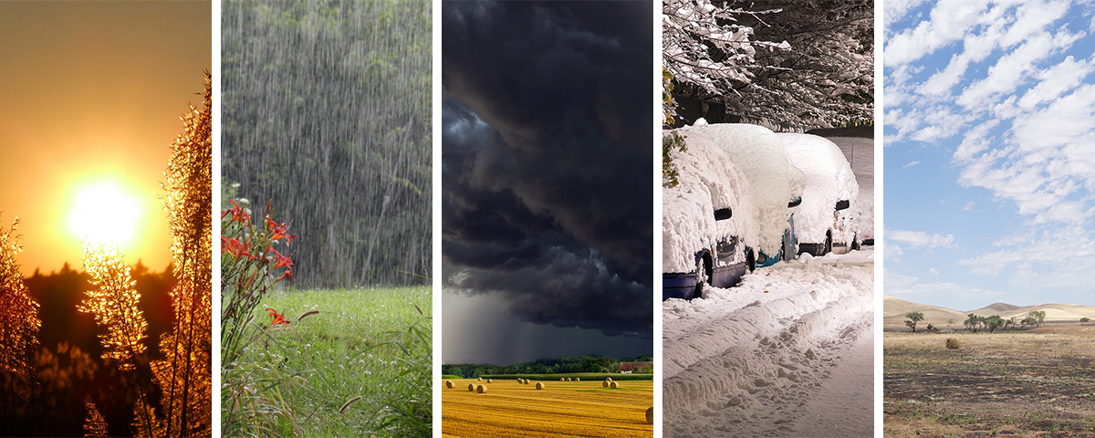
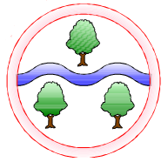
Science
Living things and their habitats
Evolution and Inheritance
Adaptation & Classification
Geography
Climate:
To know the difference between weather and climate

To explore different climate zones, extreme weather and the consequences of climate change
Mathematics
Place Value
Addition
Subtraction
Multiplication
Division
Fractions
Decimals

Computing
Understanding Technology
Computing systems and networks – Communication

English
Class book
Holes by Louis Sachar
Narrative - description of a character and setting
Persuasive letter
Biography
Poetry
Newspaper Report
Narrative - suspense
Art
Exploring identity
Design and Technology
Food – Origins of ingredients

Topic Name
‘World of Wonders’

RE
What does it mean to be human? Is being happy the greatest purpose in life?
Languages
French weather and the water cycle
Music
Blues
PSHE
Autumn 1: Healthy Relationships
Autumn 2: Money Matters

PE
Autumn 1: Dodgeball, OAA and multi-skills
Autumn 2: Golf, gymnastics and multi-skills

Ghyllgrove Community Primary School
Year 6 Autumn

