
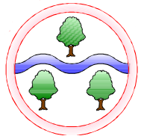
Mathematics
Multiplication and Division
Geometry: Shape
Operations Consolidation
Fractions
Statistics
Computing
E-Safety and Digital Literacy
Creating Media: Photo Editing
English
Fronted Adverbials
Subordinate Clauses
Using a wider range of conjunctions, adverbs and prepositions
Plan and compose different text types
Evaluate and edit
Using correct punctuation including inverted commas

Art
Exploring Still Life
Surfaces and Colours
Design and Technology
Designing, making and evaluating instruments
Time Travellers
Spring 1: Rock Stars
Spring 2: Essex Explorers
History and Geography
Human and Physical features
Map Skills
Types of Settlement

Science
How sound is made
How sound travels
Pitch
Volume
Observing and predicting

RE
Hinduism
Christianity

Languages
French transport
Music
Pentatonic Melodies & Composition
(Chinese New Year)
PSHE
Living in the Wider World: Money management, aspirations & the environment

PE
Swimming
Gymnastics
Handball
Ghyllgrove Community Primary School
Year 4 Spring

