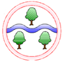
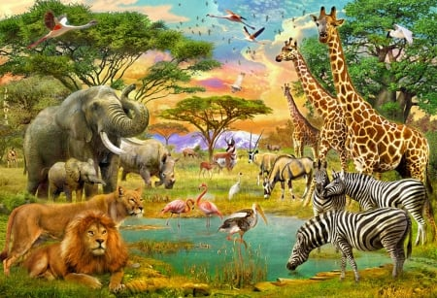
Ghyllgrove Community Primary School
Reception: Spring 2

Literacy/CAL
Selection of story books linked to topic

Capital Letters

Finger Spaces

Full-Stops

Daily Read Write Inc.
Topic: Animals Around the World
Mathematics
Addition

Number Bonds to 5

One less

Subtraction within 5

EAD

Printing

Colour Mixing

Easter Art

Kapow Music
UW
Exploring different countries and their animals

Maps and globes

St. David’s Day

St. Patrick’s Day

PSED
Being kind, staying safe, making good choices, sharing, friendships, celebrating differences.

PD
P.E, dance, cutting, healthy eating
Language of the Month

March: Shona

April: Cantonese

