**Translation of School Website Support and Guidance**

Website visitors can use their browser’s built-in translation feature to view the school website in their preferred language.

Below are official guides for commonly used browsers:

* Google Chrome
* Microsoft Edge
* Apple Safari

**Google Chrome:**

**Computer**

**1. Translate pages in Chrome**

You can use Chrome to translate a page into other languages.

1. On your computer, open Chrome.
2. Go to a page you want to translate.
3. On the right of the address bar, select Translate .
   * You can right-click anywhere on the page and select **Translate to [Language]**.
4. Select your preferred language.
   * If Translate doesn’t work, refresh the page.

**2. You can translate a section of a page**

1. On your computer, open Chrome.
2. Go to a page you want to translate.
3. Highlight the text you want to translate.
4. Right-click the highlighted text.
5. Select **Translate selection to [Language]**.

**3. Change the language of your Chrome browser**

On Windows computers, you can set Chrome to show all settings and menus in your preferred language.

**Important:**

* **Chromebook:** To add or remove web content languages on your Chromebook, [learn how to manage your Chromebook’s languages](https://support.google.com/chromebook/answer/1059490).
* **Mac or Linux:** Chrome will automatically display in the default system language for your Mac or Linux.

1. On your Windows computer, open Chrome.
2. At the top right, select More More and then **Settings**.
3. On the left, select **Languages**.
4. Under "Preferred languages," next to the language you'd like to use, select More More.
   * If the language isn't listed, add it by clicking **Add languages**.
5. Select **Display Google Chrome in this language**.
   * This option is only available on Windows computers.
6. Restart Chrome to apply the changes.

**Android**

**1. Translate pages in Chrome**

You can use Chrome to translate a page into other languages.

1. On your Android device, open Chrome Chrome.
2. Go to a page you want to translate.
3. In the notification at the top of the screen, tap the language that you want to translate the page to.
   * To change the default language:
     1. Tap Settings Settings and then **More languages**.
     2. Select the language.
   * To always translate pages in this language, tap Settings Settings and then **Always translate pages in [language]**.

**2. Change the language of Chrome**

You can choose the default language of your Chrome app's menus and settings.

1. On your Android device, open Chrome Chrome.
2. To the right of the address bar, tap More  and then **Settings** and then **Languages**.
3. Under “Chrome’s language,” tap the current language.
4. From the list, select the language you want.
5. After the language downloads, in the toolbar, tap **Restart**.

When you find “Language ready” under your new language, the download is complete.

**iPhone and iPad**

**1. Translate pages in Chrome**

You can use Chrome to translate a page into other languages.

1. On your iPhone or iPad, open Chrome Chrome.
2. Go to a page you want to translate.
3. At the top, select the language you want to translate to.
   * To change the default language, tap Settings Settings and then **More languages**and select the language.
4. Chrome will translate the page this one time.
   * To always translate page in this language, tap Settings Settings and then **Always translate [language]**.

**2. Request translation in Chrome**

If you don’t find **Translate** at the top of a page, you can request a translation.

1. On your iPhone or iPad, open Chrome Chrome.
2. Tap More More and then **Translate**.

If Chrome doesn't offer to translate, try refreshing the page. If you still can't tap **Translate**, the language might not be available for translation.

**Microsoft Edge:**

If you open a page written in a different language than your preferred languages in settings, [Microsoft Edge](https://www.microsoft.com/edge) will automatically prompt you to translate it.

The Translate icon Translator appears in the address bar when you go to a web page that’s written in a foreign language. A language is considered foreign to you if it's not included in your **Preferred languages** list in Settings. To add or remove languages from the list, in Microsoft Edge, go to **Settings and more** > **Settings**> **Languages**.

**1. Translate a webpage in Microsoft Edge**

1. Open a webpage in Microsoft Edge. The browser will detect the language of the page, and a menu will appear asking you to confirm that you want to translate the page.  
     
   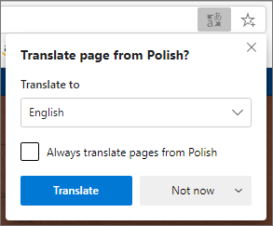
2. Do any of the following:
   * In the **Translate to** dropdown, choose the language you want the page translated into. The default is the language you've set for Microsoft Edge.
   * To translate the page, click **Translate**.
   * To always automatically translate from the source language, select the **Always translate from [Language]** check box.
   * To skip translation, in the list on the lower right, select **Not now** to skip translation or **Never translate [Language]** to never have the panel appear when you go to a page using that language.  
       
     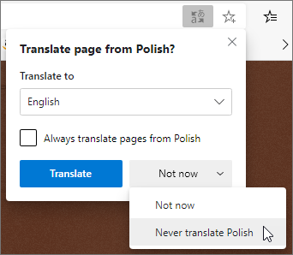

**Note:**You can manually return to this panel later, even if you select the option to **Never translate**.

1. Inside the address bar, you'll briefly see the status showing that the page has been translated.  
     
   Translated status in the search bar  
     
   If you select the translate icon Translator in the address bar, the menu that appears also shows the status.  
     
   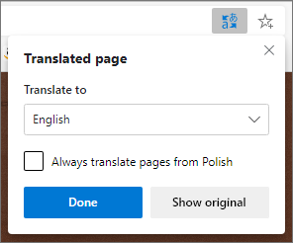

**2. Manually translate webpage**

If you've set Microsoft Edge to never translate a specific language, you won't see an automatic pop-up prompting you to translate. However, you'll still be able to translate it manually at any time.

To translate the page into a different language:

1. Select the translate icon Translatorin the address bar.
2. In the **Translate to** menu, select which language you want to translate to.  
     
   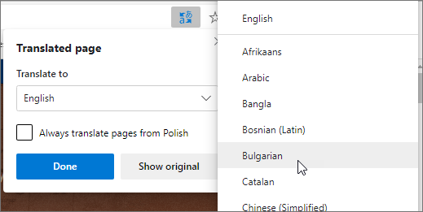
3. Select **Translate**.

**3. Revert translated webpage back to original language**

1. On the address bar, select the translate icon  Translator.
2. Select **Show original**.  
     
   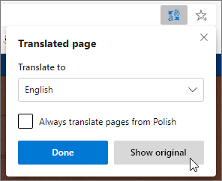

**Turn translation in Microsoft Edge on or off**

By default, Microsoft Edge will automatically prompt page translations.

To modify this setting:

1. At the top corner of the browser, select **Settings and more** <null> > **Settings**.
2. Select **Languages**.
3. Enable or turn off **Offer to translate pages that aren't in a language I read**.

By default, Microsoft Edge uses the same language as your system. For more information about using different languages in Microsoft Edge, learn how to [use Microsoft Edge in another language](https://support.microsoft.com/en-us/help/4532129/microsoft-edge-use-in-another-language).

**Apple Safari:**

**1. Translate text or your voice**

1. Go to the Translate app  on your iPhone.
2. Tap the language you want to translate your selected text to.

To swap languages, tap the Language Swap button.

1. Tap one of the following:
   * *Translate text:* Tap “Enter text,” type a phrase (or paste text), then tap Next in the keyboard.

You can also tap Done in the top-left corner of the screen.

* + *Translate your voice:* Tap the Listen button, then say a phrase.

*Note:*Words are translated as you type or speak.

1. When the translation is shown, do any of the following:
   * *Play the audio translation:* Tap the Play button.

**Tip:**Touch and hold the Play button to adjust the playback speed.

* + *Show the translation to someone else:* Tap the Enter Full Screen button.
  + *Save the translation as a favorite:* Tap the Favorite button.
  + *Look up a word in the dictionary:*Tap the Dictionary button.
  + *Copy the translation:* Tap the Copy Button.

**Tip:**To view your recent history, swipe the translation down.

To delete a translation, swipe left, then tap the Delete button.

**2. Download languages for offline translation or On-Device Mode**

Download languages to translate when you don’t have an internet connection or when On-Device Mode is turned on.

1. Go to Settings  > Apps > Translate.
2. Do any of the following:
   * Tap Downloaded Languages, then tap the Download button next to the languages you want to download.
   * Turn On-Device Mode on.