**Top tips for staying emotionally healthy during self-isolation.**

**5 ways of wellness:**

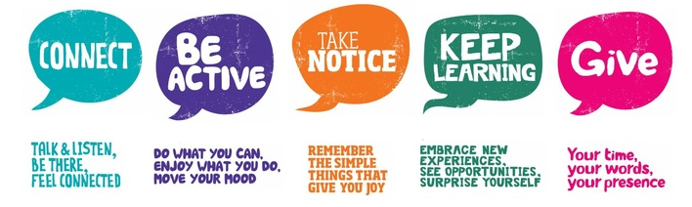

* + **Stick to a active daily routine** (e.g. creating your own daily programme including three meals a day, activity time slots, self-care opportunities and bedtime routine)
  + **Do light activity** - stretch and home workouts (e.g. yoga, dance, spring cleaning the house)
  + **Keep up hobbies that keep you moving** (e.g. baking, reading, writing, making music, gardening etc)
  + **Engage in creative activities** (e.g. art, scrap book making, junk modelling, restoring furniture, create music, redecorating)
  + **Keep connected to others** (e.g. phones, email, skype, websites, helplines & online counselling)
  + **Keep an active mind** (e.g. learning a new skill, research, brain training games, home learning using such free websites)
  + **Try Meditation and relaxation** (e.g. Apps and free YouTube videos such as headspace)
  + **Hot desk at home with planned short brain breaks**
  + **Plan meals in advance**
  + **Do things you enjoy doing** (e.g. watch a boxset, paint your nails, listen to podcasts, reading etc)
  + **Keeping hydrated**

**Self-care opportunities** (Self-care is any activity that we do deliberately in order to take care of our mental, emotional, and physical health. Although it's a simple concept in theory, it's something we very often overlook. Good self-care is key to improved mood and reduced anxiety)