Stay

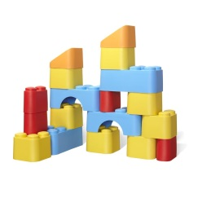and

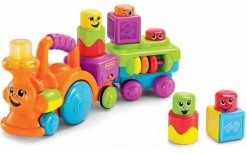Play

at Ghyllgrove

#### *The ‘Stay and Play’ sessions for this academic year will be on:*

#### **Wednesday 8th November 2017**

#### **Tuesday 16th January 2018**

#### **Wednesday 28th February 2018**

#### **Tuesday 24th April 2018**

#### **Wednesday 13th June 2018**

#### **10.00 - 11.00 a.m.**

Anyone with a baby or child with a hearing loss is welcome to attend.

(brothers and sisters are also welcome to come and play)

*The sessions will be held at*

Ghyllgrove Primary Resource Base for Hearing-Impaired Children,

Ghyllgrove **Junior** School,

The Gore, Basildon SS14 2BG

waterschool 1tree

