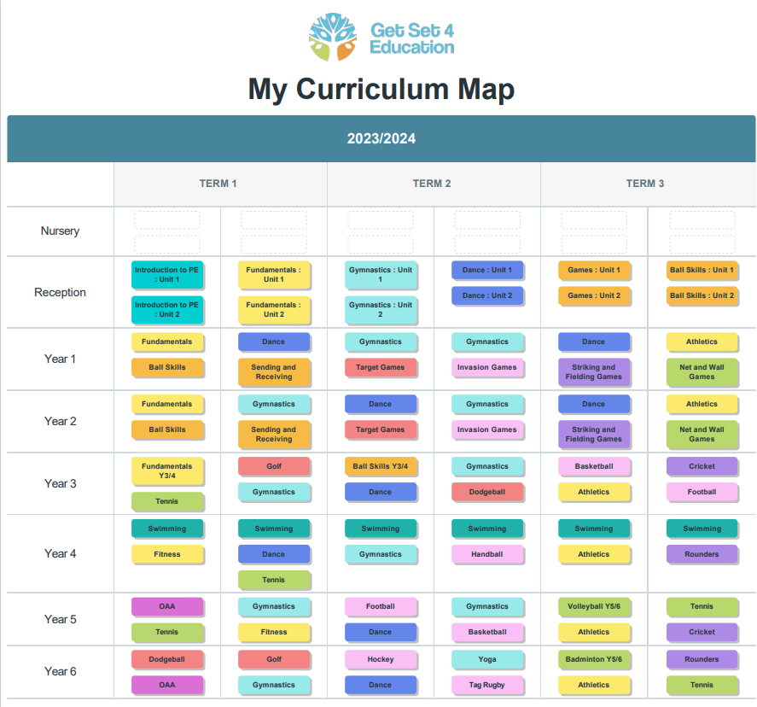

**Aims of our PE curriculum**

At Ghyllgrove Primary School we recognise the importance PE plays in the curriculum and are committed to providing all children with opportunities to engage fully in Physical Education. The aim of our PE programme is to develop children's basic physical competencies, build confidence in their ability and build the foundations for a lifelong love of sport, physical activity and a healthy lifestyle. PE lessons encourage children to compete against themselves and others whilst being challenged to improve their physical, social, emotional and thinking skills. These skills are embedded in the heart of our planning. Our objectives in the teaching of PE align with the National Curriculum in that we aim to ensure all pupils:

* Develop competence to excel in a broad range of physical activities
* Are physically active for sustained periods of time
* Engage in competitive sports and activities
* Lead healthy, active lives

**Teaching and learning**

Our PE lessons are planned using the Get Set 4 PE platform, which aligns with our core values, our whole child approach to PE and the objectives laid out in the National Curriculum. Get Set 4 PE is planned so that progression is built into the scheme which ensures our children are increasingly challenged as they move up through the school.

The curriculum planning in PE is carried out in three phases (long-term, medium-term and shortterm). The long-term plan maps out the PE activities covered in each term during the key stage. The PE subject leader works this out in conjunction with teaching colleagues and pupils in each year group. Together we create a broad and balanced curriculum that is exciting for our children to learn through. Our medium-term plans give details of each unit of work for each term. These schemes of work provide an overview of the unit, links to other areas of the National Curriculum and assessment criteria for that unit. The short-term lesson plans provide opportunities for children of all abilities to develop their skills, knowledge and understanding in each activity area. P.E is taught twice a week in Ghyllgrove Primary School.

**EYFS**

We encourage the physical development of our children in the nursery and reception class as an integral part of their work. As these classes are part of the Foundation Stage of the National Curriculum, we relate the physical development of the children to the objectives set out in the Early Learning Goals, which underpin the curriculum planning for children aged three to five years of age. We encourage the children to develop confidence and control of the way they move, and the way they handle tools and equipment. We give all children the opportunity to undertake activities that offer appropriate physical challenge, both indoors and outdoors, using a wide range of resources to support specific skills.

**Health and Safety**

We recognise that participation in PE and Physical Activities contains an element of risk. Staff are responsible for ensuring that they are familiar with safe practice to reduce the element of risk to the absolute minimum within their control. Staff are aware of pupils who have special needs with regards to physical activity and make special provision for needs where appropriate e.g. physical disability, asthma. Staff know about the safe practices involved in moving and using apparatus. Pupils wear appropriate clothing, remove jewellery and tie back long hair. If the removal of jewellery or studs is not possible they should be securely taped and the teacher is confident this strategy is effective. Our School provides an appropriate PE kit for all children and keeps spare sets in school.

* Correct use of equipment is taught along with any potential hazards, including completing a risk assessment for each area/ space that PE and school sport takes place in.
* Equipment and apparatus are stored safely at the end of each lesson.
* Pupils are taught to consider their own safety and that of others at all times.

Teaching staff should be appropriately dressed to teach PE. We undertake an annual Risk Assessment of the school premises and areas where PE is taught and equipment including PE equipment (PE Lead) as necessary. Risk Assessments are in place for all school sporting trips.

.E**Statutory guidance**

**National curriculum in England: physical education programmes of study**

**Purpose of study**

A high-quality physical education curriculum inspires all pupils to succeed and excel in competitive sport and other physically demanding activities. It should provide opportunities for pupils to become physically confident in a way which supports their health and fitness. Opportunities to compete in sport and other activities build character and help to embed values such as fairness and respect.

**Aims**

The national curriculum for physical education aims to ensure that all pupils:

* develop competence to excel in a broad range of physical activities
* are physically active for sustained periods of time
* engage in competitive sports and activities
* lead healthy, active lives

**Attainment targets**

By the end of each key stage, pupils are expected to know, apply and understand the matters, skills and processes specified in the relevant programme of study.

**Subject content**

**Key stage 1**

Pupils should develop fundamental movement skills, become increasingly competent and confident and access a broad range of opportunities to extend their agility, balance and coordination, individually and with others. They should be able to engage in competitive (both against self and against others) and co-operative physical activities, in a range of increasingly challenging situations.

Pupils should be taught to:

* master basic movements including running, jumping, throwing and catching, as well as developing balance, agility and co-ordination, and begin to apply these in a range of activities
* participate in team games, developing simple tactics for attacking and defending
* perform dances using simple movement patterns

**Key stage 2**

Pupils should continue to apply and develop a broader range of skills, learning how to use them in different ways and to link them to make actions and sequences of movement. They should enjoy communicating, collaborating and competing with each other. They should develop an understanding of how to improve in different physical activities and sports and learn how to evaluate and recognise their own success.

Pupils should be taught to:

* use running, jumping, throwing and catching in isolation and in combination
* play competitive games, modified where appropriate [for example, badminton, basketball, cricket, football, hockey, netball, rounders and tennis], and apply basic principles suitable for attacking and defending
* develop flexibility, strength, technique, control and balance [for example, through athletics and gymnastics]
* perform dances using a range of movement patterns
* take part in outdoor and adventurous activity challenges both individually and within a team
* compare their performances with previous ones and demonstrate improvement to achieve their personal best

**Swimming and water safety**

All schools must provide swimming instruction either in key stage 1 or key stage 2.

In particular, pupils should be taught to:

* swim competently, confidently and proficiently over a distance of at least 25 metres
* use a range of strokes effectively [for example, front crawl, backstroke and breaststroke]
* perform safe self-rescue in different water-based situations

Published 11 September 2013