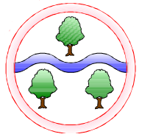****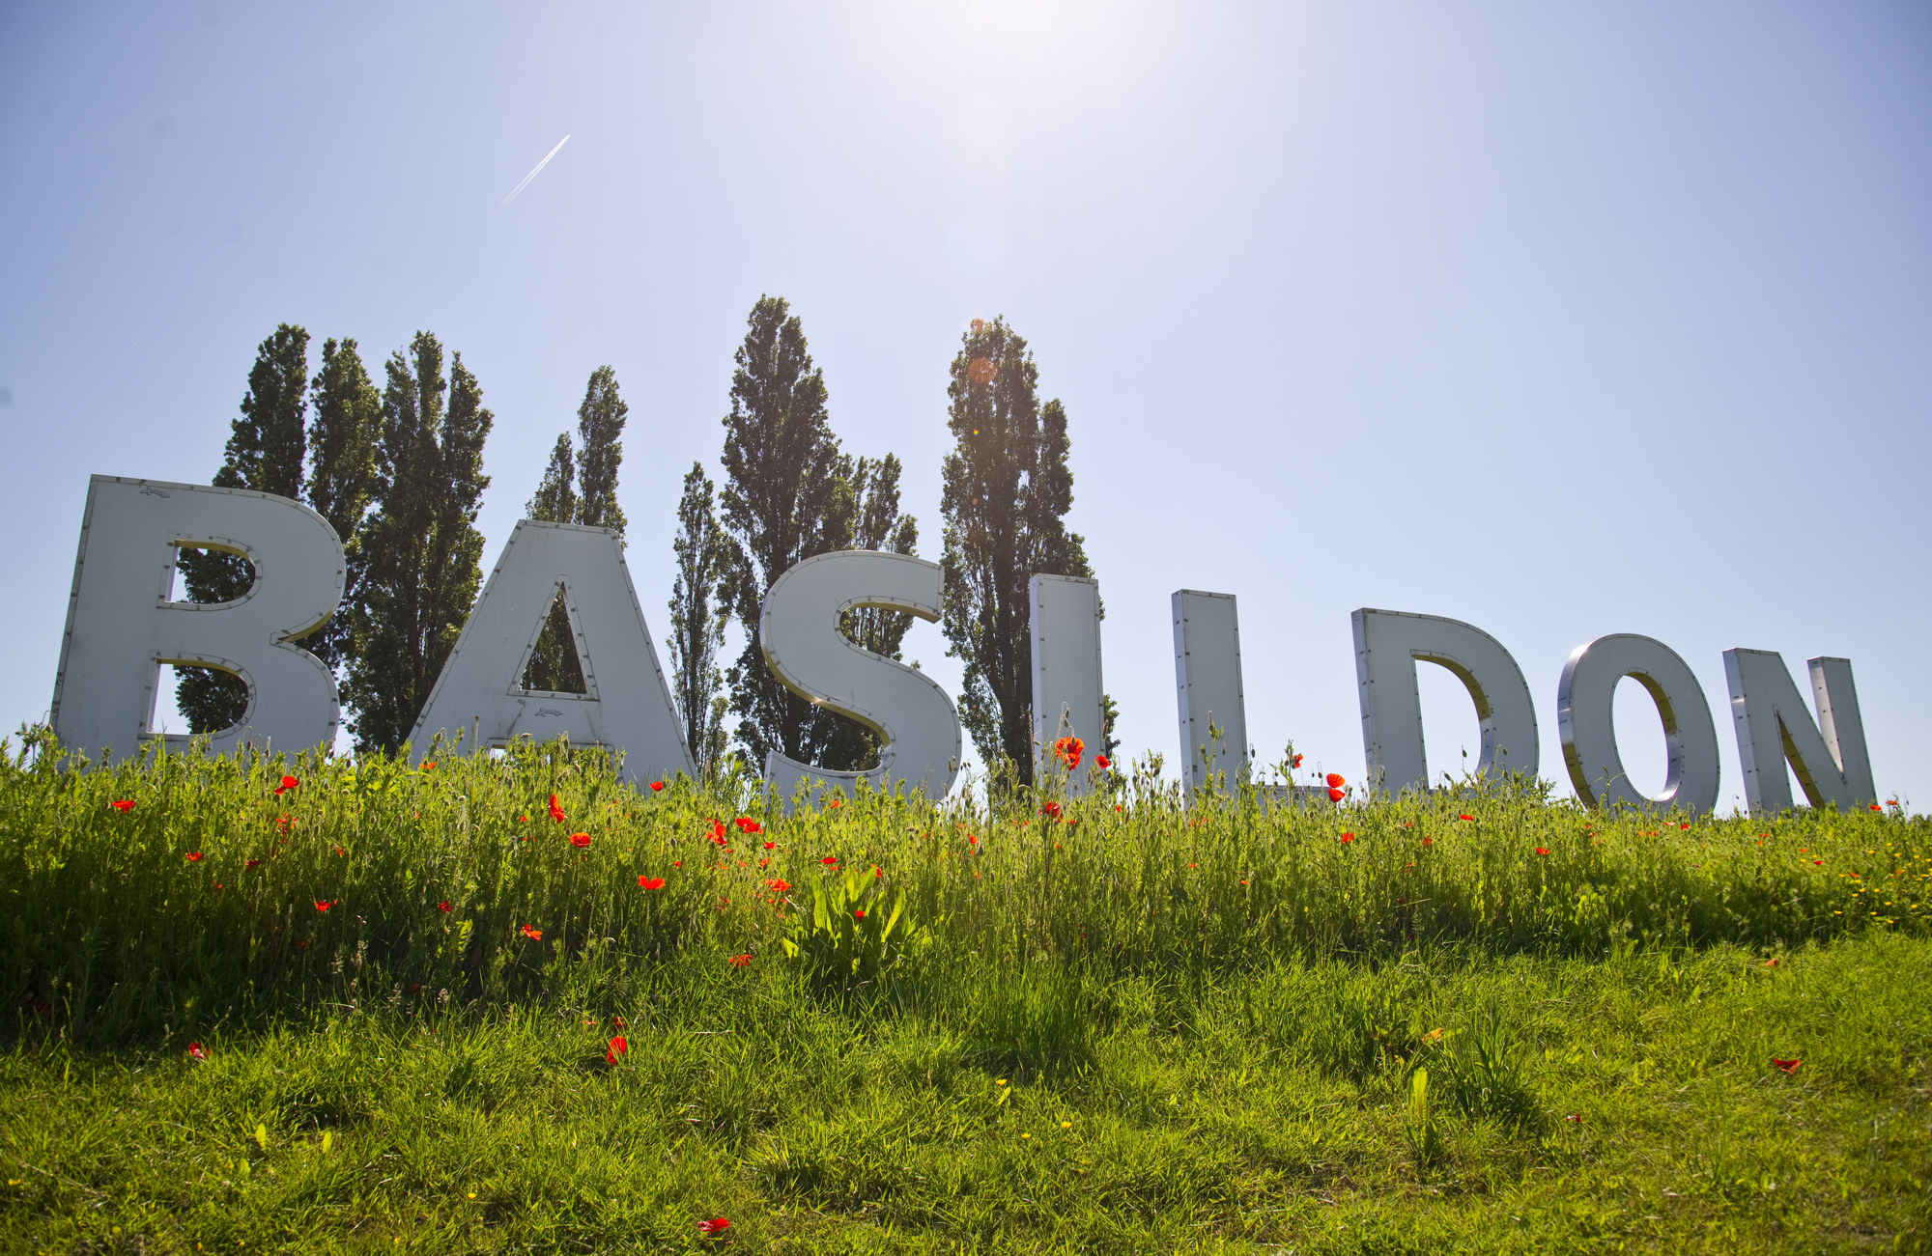

**Ghyllgrove Community Primary School**

Nursery: Autumn

**Literacy/CAL**

We will read stories that are linked to the season autumn

Talk about and learn new words around our topic

Mark making

Introduce environmental sounds

Developing listening skills through games and circle times

Share short story books

Introduce self-registration names/ coat peg names to identify

Musical instruments

**PSED**

Autumn 1: Support transition to nursery, develop relationships to provide a secure base to return to for reassurance, develop confidence in the environment, develop independent self-care

Autumn 2: Introduce class rules and expectations, turn taking and sharing by modelling behaviour

**PD**

Autumn 1: Practice washing hands/ going to the toilet, using equipment safely, build with recourses, dancing and using fine motor movements during playdough

Autumn 2: Practice putting on coat, large movements clap and stomp to music, encourage the children to help with sweeping and tidying up, play games

**Language of the Month**

Sept: Lithuanian Oct: Polish

Nov: Turkish Dec: Romanian

**UW**

Learn each other’s names

Season changes

Weather changes

Celebrations- birthdays, bonfire night, Remembrance Day and Christmas

**EAD**

Explore paint using a range of tools and media

Mirrors and improvises actions

Make simple models

Songs and rhymes

**Topic Name**

**Autumn**: Looking at the changing season

**Mathematics**

Logic and reasoning during tidying up routine

Move through spaces

Emptying and filling containers

Counting

Finger numbers up to 5.

Number recognition

Introduce number songs and rhymes

Puzzles