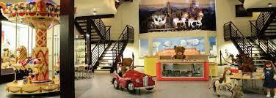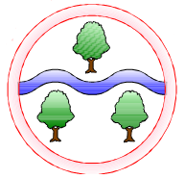

**English  
Phonics**

Read Write Inc

**Reading**

A selection of Fiction and Non-Fiction texts  
 **Writing**

Using full stops

Using capital letters  
Finger spaces

Using ‘and’ to join two words

Exclamation marks

Question marks

**Music**

Charanga:

In the groove

Round and Round

**Toy Museum –** we will be learning about everyday materials and their properties. How toys have changed through living memory and making our own toy.

**Ghllgrove Gardeners –** Studying different plants and trees and how things grow and change.

**History   
Spring 1**:  
**History** - Changes within living memory - how toys have changed

**Science  
Spring 1:** Everyday materials and their properties

**Spring 2**:

Plants,trees; deciduous and evergreen, life cycle of a plant and how fruit and vegetables grow

**Mathematics**

**Place Value**

Within 20

Within 50

**Addition and Subtraction**

Within 20

**Measurement**

Length and height

Mass and volume

**Computing**

E-Safety & Understanding Technology

**Art**

Observational drawings

**Design and Technology**

Design a Toy - Strengthen Structures

Food Technology – Fruit kebabs

**RE**

Judaism

**Language of the Month**

**Jan**: Bengali **Feb**: Urdu

**Mar**: Shona **Apr**: Chinese

**PSHE**

The human life cycle, healthy bodies

**PE**

Gymnastics

Target games

Invasion games

**Ghyllgrove Community Primary School**

Year 1 Spring 2024