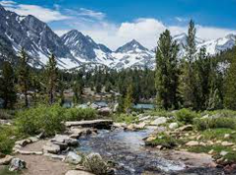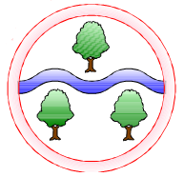

**Ghyllgrove Community Primary School Year 5 Summer**

**Ghyllgrove Community Primary School**

Year 5 Spring

**Mathematics  
Four operations consolidation**

**Geometry shape**Geometry: position and direction

**Negative numbers**

**Decimals**

**Measurement:**

Converting units  
volume

**Computing**

Coding an educational quiz using scratch

**English**

**Reading**

Harry Potter and the Philosopher’s Stone

**Writing**

Using relative clauses

Modal verbs and adverbs of possibility

Fronted Adverbials

Range of sentence structures

Parenthesis

Connectives for cohesion

**Design and Technology**

Structures – Building a bridge

**Topic Name**

**Summer 1: Summit to Sea**

**Summer 2: Invaders and Settlers**

**History**

Saxons and Vikings

**Geography**

Atlas skills

Features of mountains and rivers

**Science**

**Forces**

Water resistance

**RE**

Theology – How do Hindus make sense of the world?

**Languages**

Classroom items  
asking and answering questions

**Music**

The history of music

Jazz

**PSHE**

Summer 1: Living in the wider world

Summer 2: Puberty

**PE**

Summer 1 and 2:

Volleyball and Athletics

**Art**

Typography